##1. How to extract all odd numbers from arr?

import numpy as np

arr = np.array([0, 1, 2, 3, 4, 5, 6, 7, 8, 9])

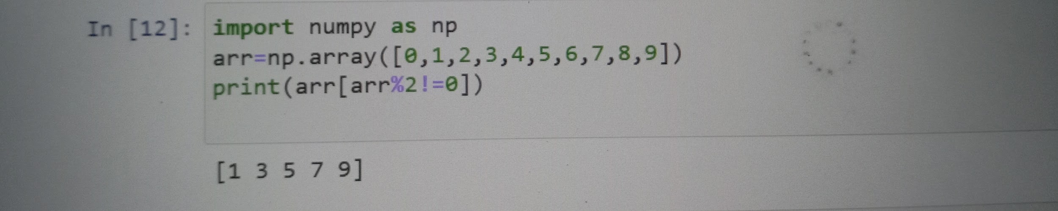

##2. Replace all odd numbers in arr with -1 without changing

import numpy as np

arr = np.array([0, 1, 2, 3, 4, 5, 6, 7, 8,9])

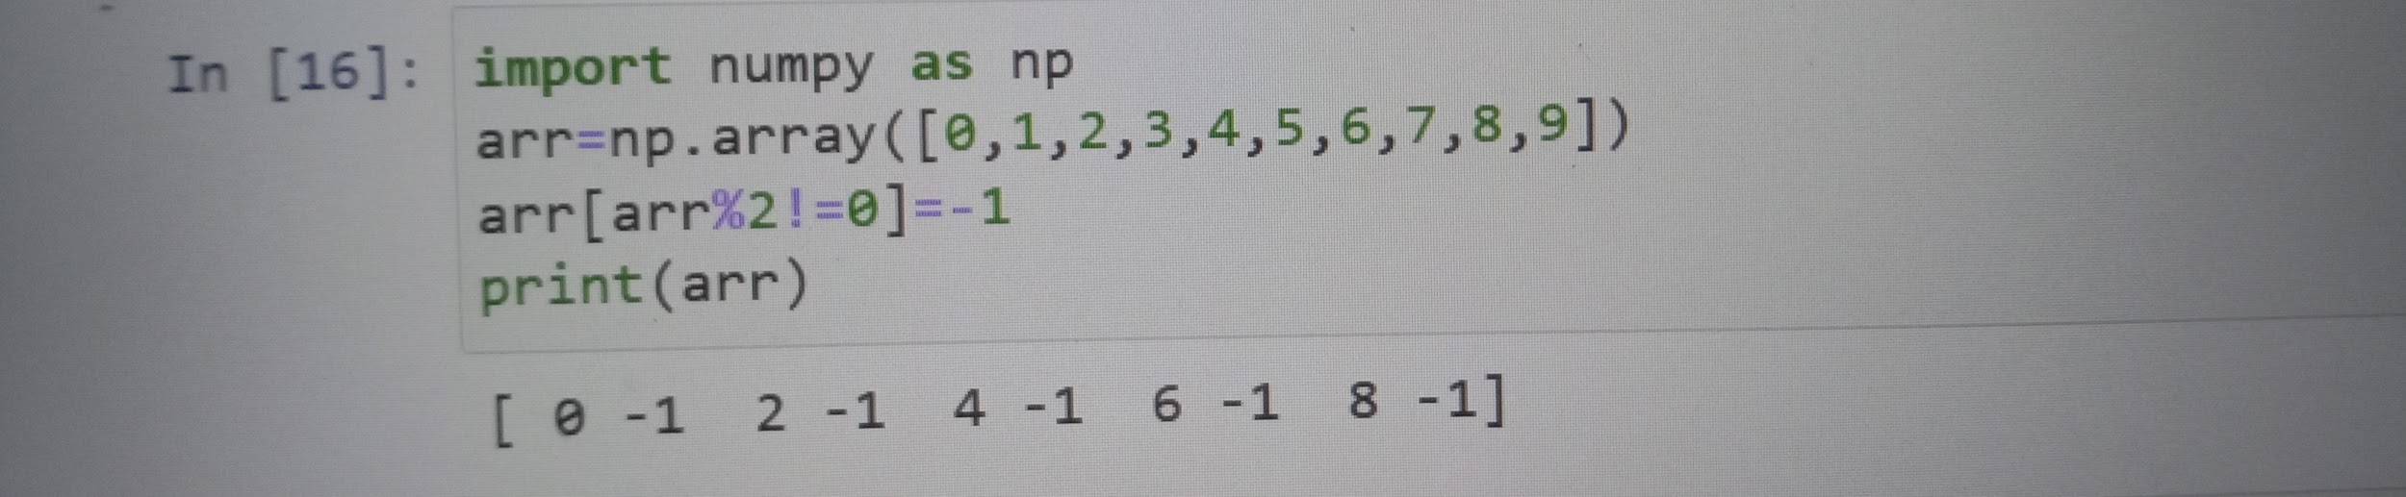

##3. Convert a 1D array to a 2D array with 2 rows

import numpy as np

arr=np.arange(10)

#Desired Output:

#> array([[0, 1, 2, 3, 4],

#> [5, 6, 7, 8, 9]])

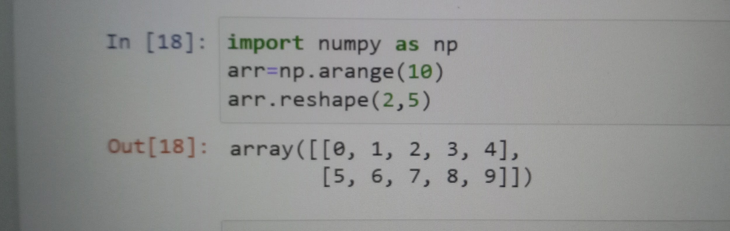

##4. Stack arrays a and b vertically

import numpy as np

a = np.arange(10).reshape(2,-1)

b = np.repeat(1, 10).reshape(2,-1)

#Desired Output:

#> array([[0, 1, 2, 3, 4],

#> [5, 6, 7, 8, 9],

#> [1, 1, 1, 1, 1],

#> [1, 1, 1, 1, 1]])

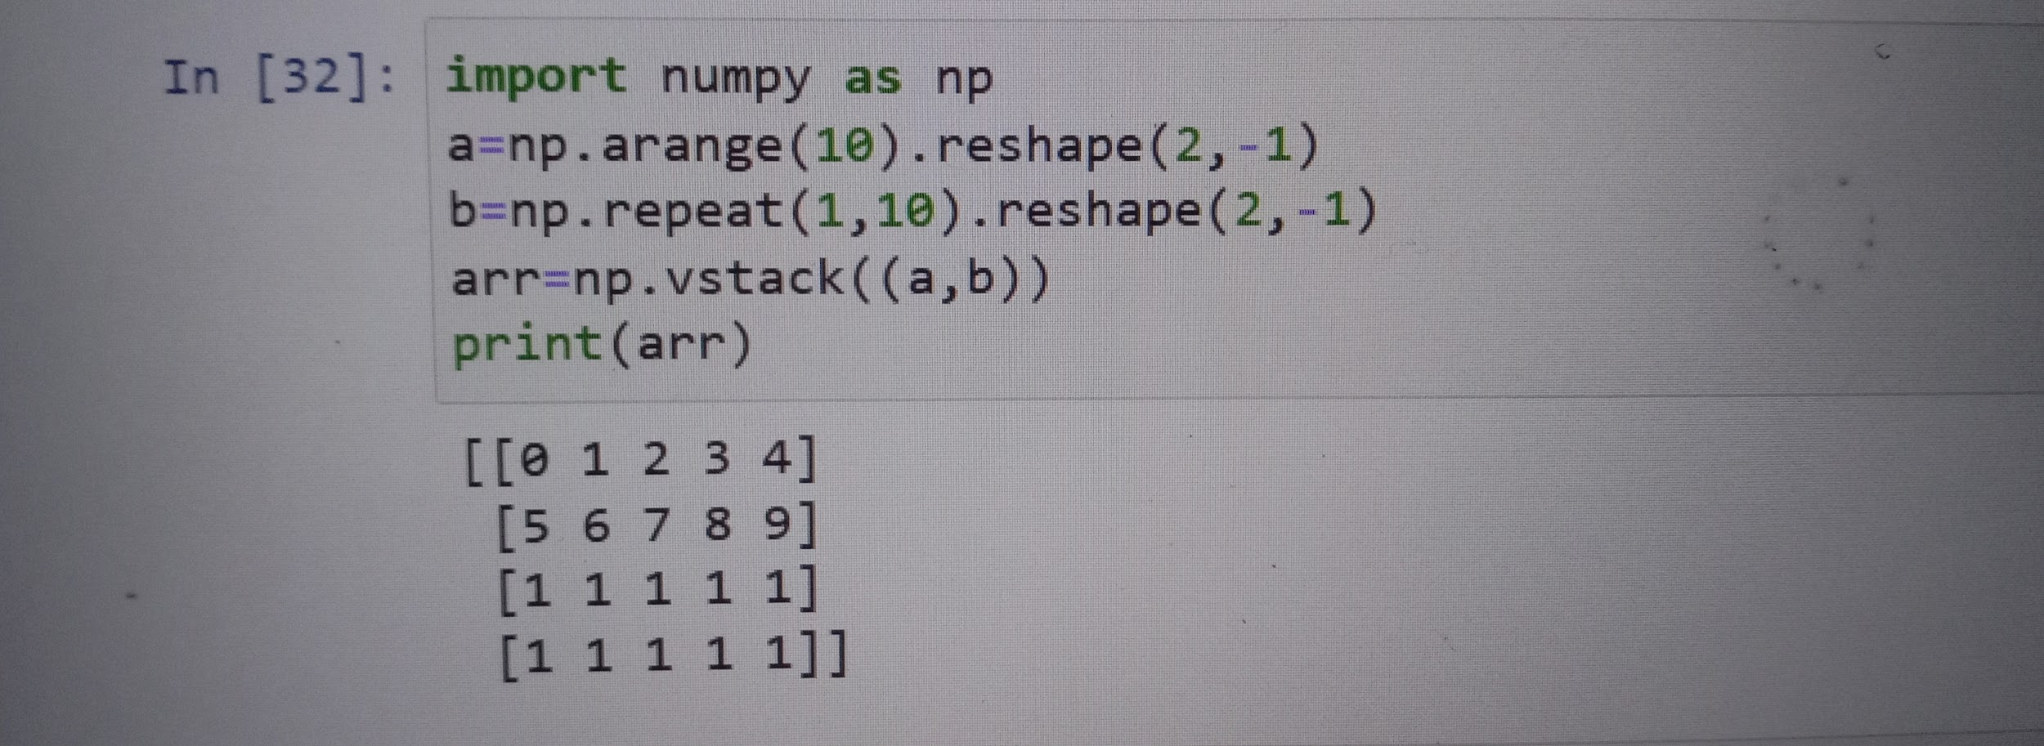

##5. Stack the arrays a and b horizontally.

import numpy as np

a = np.arange(10).reshape(2,-1)

b = np.repeat(1, 10).reshape(2,-1)

#Desired Output:

#> array([[0, 1, 2, 3, 4, 1, 1, 1, 1, 1],

#> [5, 6, 7, 8, 9, 1, 1, 1, 1, 1]])

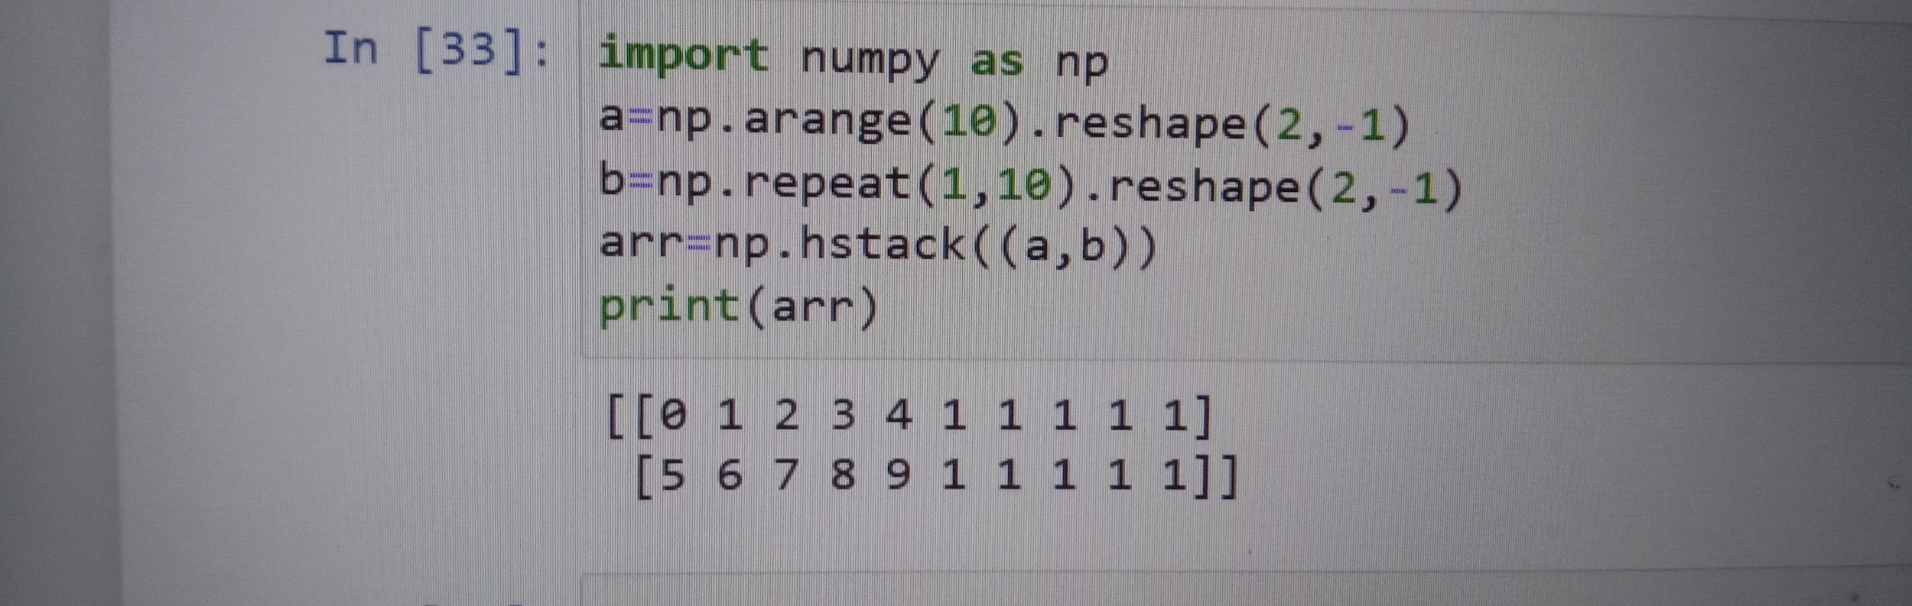

##6.How to get the common items between two python numpy arrays?

Get the common items between a and b

import numpy as np

a = np.array([1,2,3,2,3,4,3,4,5,6])

b = np.array([7,2,10,2,7,4,9,4,9,8])

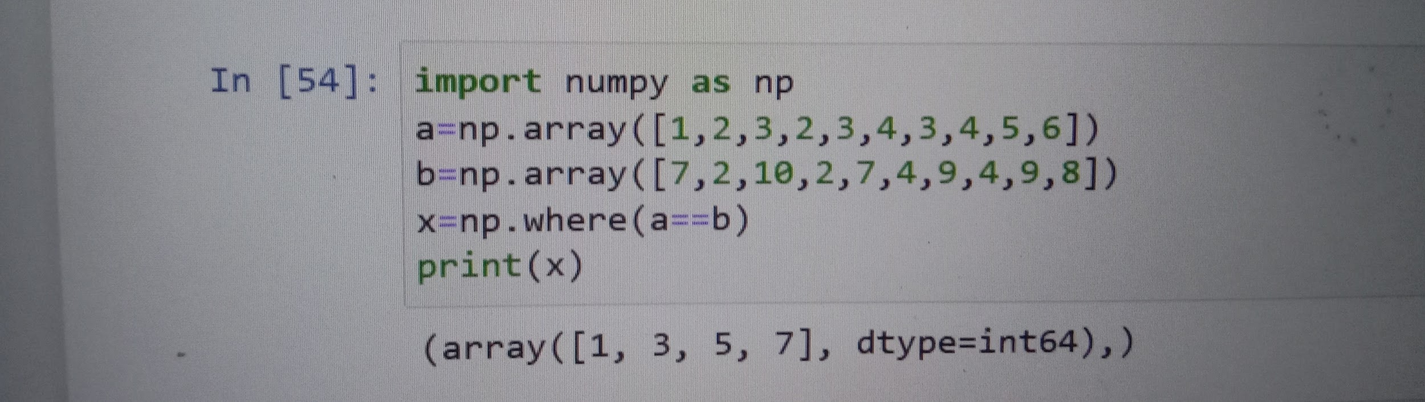

##7.How to remove from one array those items that exist in another?

Q. From array a remove all items present in array b

import numpy as np

a = np.array([1,2,3,4,5])

b = np.array([5,6,7,8,9])



##8. How to get the positions where elements of two arrays match?

Q. Get the positions where elements of a and b match

import numpy as np

a = np.array([1,2,3,2,3,4,3,4,5,6])

b = np.array([7,2,10,2,7,4,9,4,9,8])

#Desired Output:

#> (array([1, 3, 5, 7]),)



##9. How to extract all numbers between a given range from a numpy array?

Get all items between 5 and 10 from a

import numpy as np

a = np.array([2, 6, 1, 9, 10, 3, 27])

#Desired Output:

#(array([6, 9, 10]),)



##Pandas Data Series

##1. Write a Pandas program to convert a dictionary to a Pandas series.

```

Sample Series:

Original dictionary:

{'a': 100, 'b': 200, 'c': 300, 'd': 400, 'e': 800}

Converted series:

a 100

b 200

c 300

d 400

e 800

dtype: int64

```

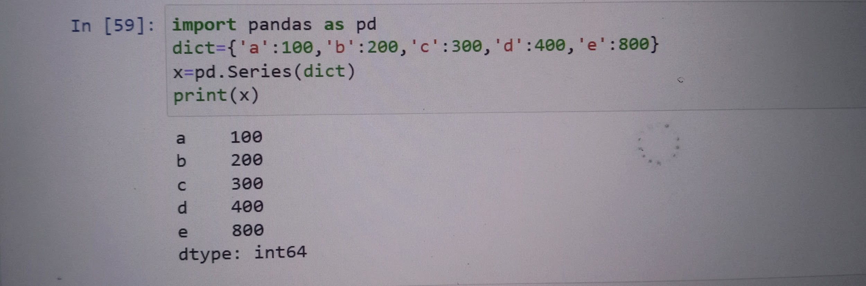

##2. Write a Pandas program to convert a NumPy array to a Pandas series.

Sample Series:

NumPy array:

[10 20 30 40 50]

Converted Pandas series:

0 10

1 20

2 30

3 40

4 50

dtype: int64

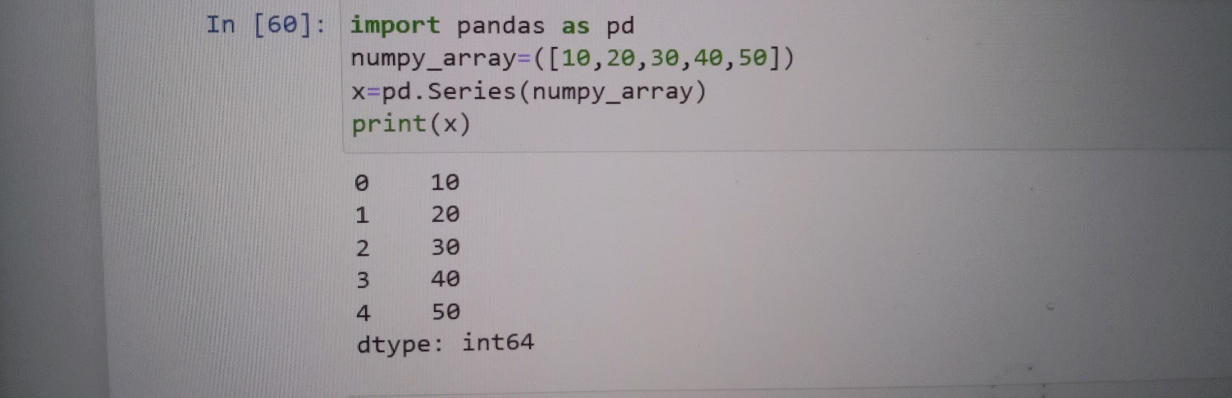

##3. Write a Pandas program to change the data type of given a column or a Series.

Sample Series:

Original Data Series:

0 100

1 200

2 python

3 300.12

4 400

dtype: object

Change the said data type to numeric:

0 100.00

1 200.00

2 NaN

3 300.12

4 400.00

dtype: float64

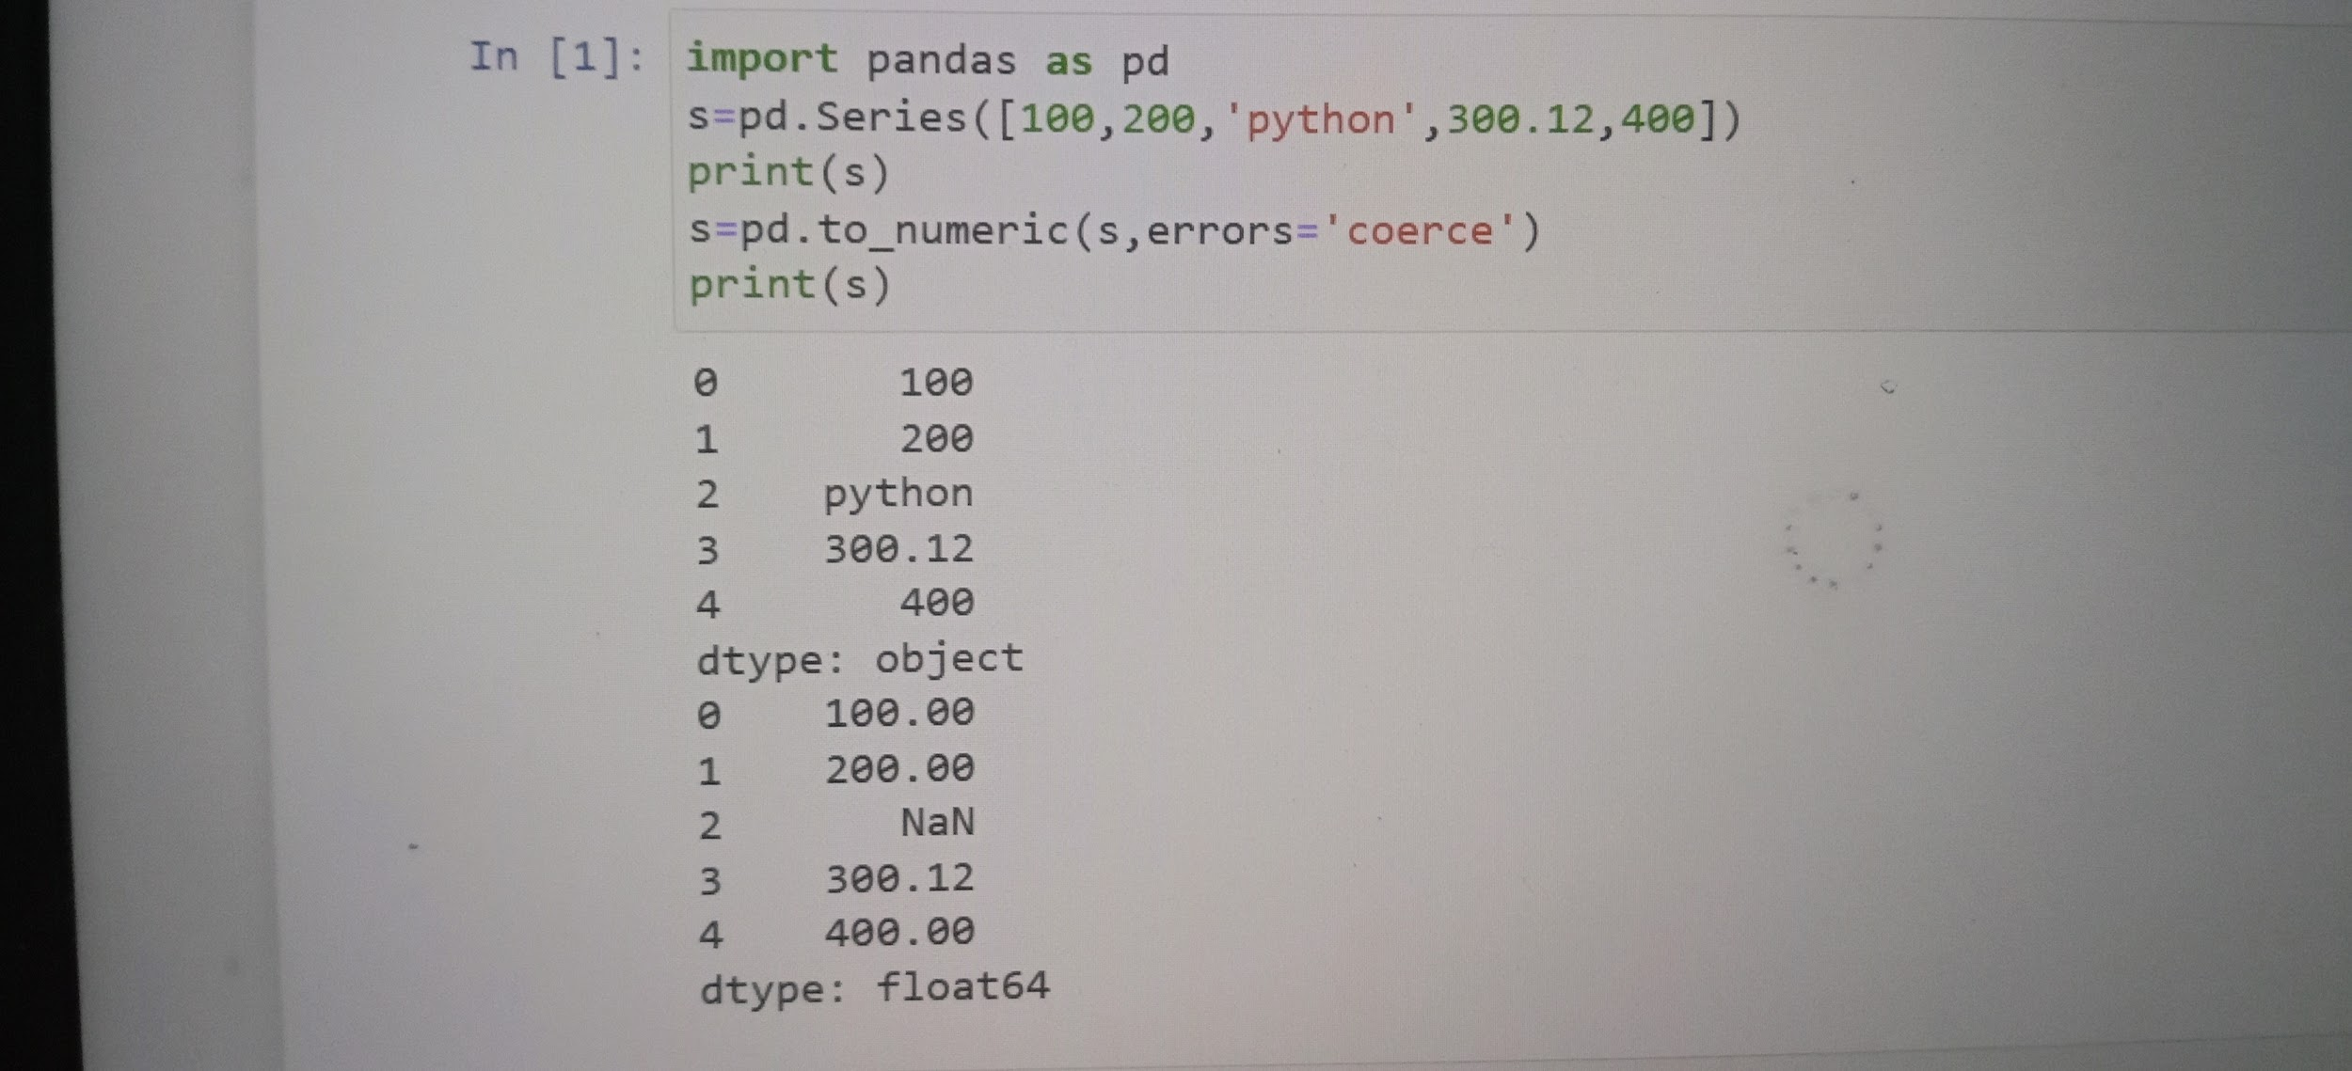

##4. Write a Pandas program to convert the first column of a DataFrame as a Series.

Sample Output:

Original DataFrame

col1 col2 col3

0 1 4 7

1 2 5 5

2 3 6 8

3 4 9 12

4 7 5 1

5 11 0 11

1st column as a Series:

0 1

1 2

2 3

3 4

4 7

5 11

Name: col1, dtype: int64

<class 'pandas.core.series.Series'>

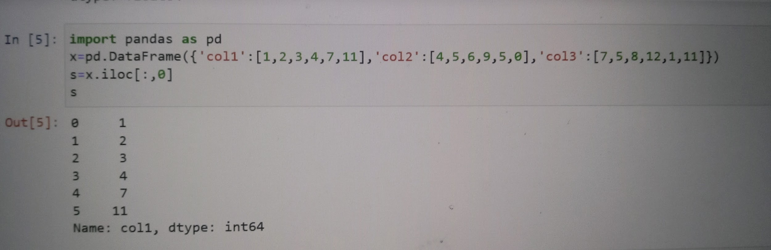

##5. Write a Pandas program to convert a given Series to an array.

Sample Output:

Original Data Series:

0 100

1 200

2 python

3 300.12

4 400

dtype: object

Series to an array

['100' '200' 'python' '300.12' '400']

<class 'numpy.ndarray'>



##6 Write a Pandas program to convert Series of lists to one Series.

Sample Output:

Original Series of list

0 [Red, Green, White]

1 [Red, Black]

2 [Yellow]

dtype: object

One Series

0 Red

1 Green

2 White

3 Red

4 Black

5 Yellow

dtype: object

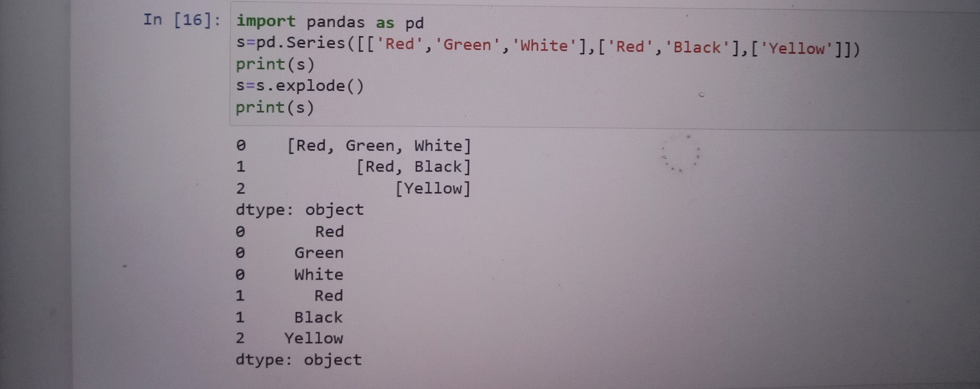

##7.Write a Pandas program to sort a given Series.

Sample Output:

Original Data Series:

0 100

1 200

2 python

3 300.12

4 400

dtype: object

0 100

1 200

3 300.12

4 400

2 python

dtype: object

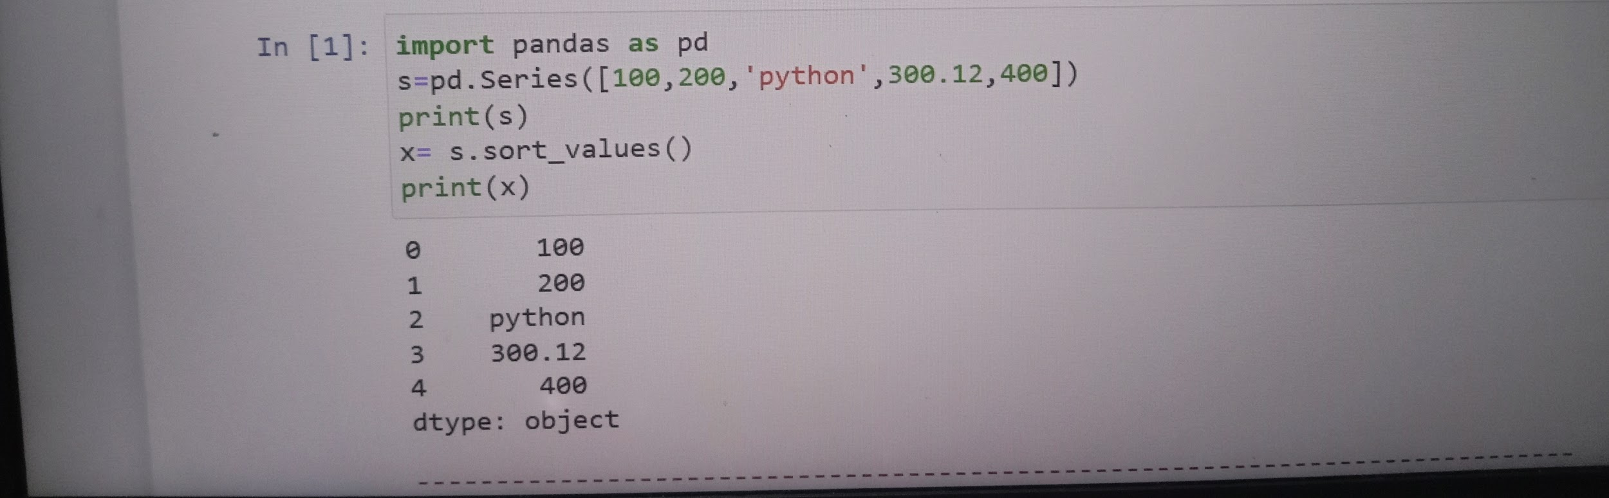

##Pandas DataFrame

##1.Write a Pandas program to create a dataframe from a dictionary and display it.

```

Sample data: {'X':[78,85,96,80,86], 'Y':[84,94,89,83,86],'Z':[86,97,96,72,83]}

Expected Output:

X Y Z

0 78 84 86

1 85 94 97

2 96 89 96

3 80 83 72

4 86 86 83

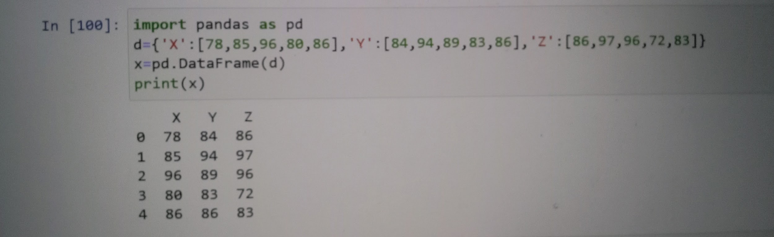

##2. Write a Pandas program to create and display a DataFrame from a specified dictionary data which has the index labels.

Sample Python dictionary data and list labels:

exam_data = {'name': ['Anastasia', 'Dima', 'Katherine', 'James', 'Emily', 'Michael', 'Matthew', 'Laura', 'Kevin', 'Jonas'],

'score': [12.5, 9, 16.5, np.nan, 9, 20, 14.5, np.nan, 8, 19],

'attempts': [1, 3, 2, 3, 2, 3, 1, 1, 2, 1],

'qualify': ['yes', 'no', 'yes', 'no', 'no', 'yes', 'yes', 'no', 'no', 'yes']}

labels = ['a', 'b', 'c', 'd', 'e', 'f', 'g', 'h', 'i', 'j']

Expected Output:

attempts name qualify score

a 1 Anastasia yes 12.5

b 3 Dima no 9.0

....

i 2 Kevin no 8.0

j 1 Jonas yes 19.0

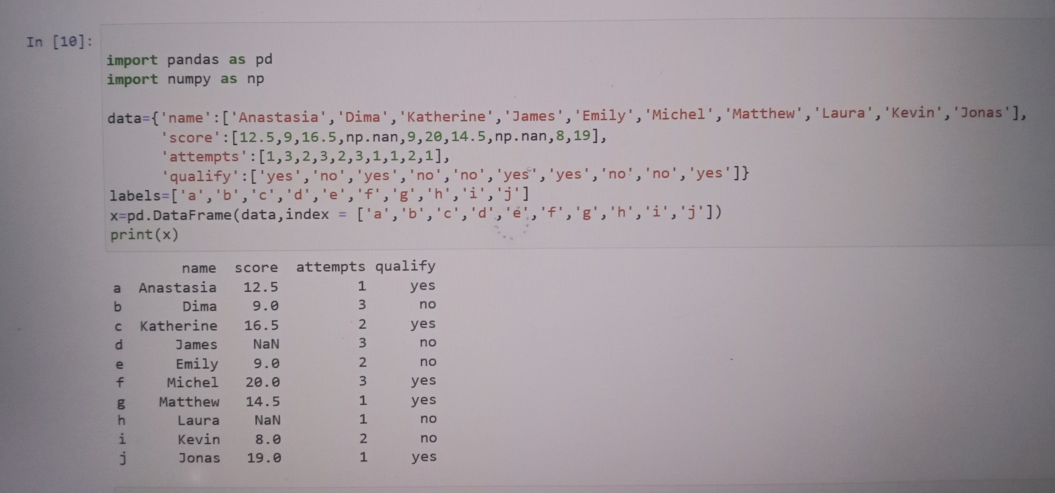

##3. Write a Pandas program to get the first 3 rows of a given DataFrame.

```

Sample Python dictionary data and list labels:

exam_data = {'name': ['Anastasia', 'Dima', 'Katherine', 'James', 'Emily', 'Michael', 'Matthew', 'Laura', 'Kevin', 'Jonas'],

'score': [12.5, 9, 16.5, np.nan, 9, 20, 14.5, np.nan, 8, 19],

'attempts': [1, 3, 2, 3, 2, 3, 1, 1, 2, 1],

'qualify': ['yes', 'no', 'yes', 'no', 'no', 'yes', 'yes', 'no', 'no', 'yes']}

labels = ['a', 'b', 'c', 'd', 'e', 'f', 'g', 'h', 'i', 'j']

Expected Output:

First three rows of the data frame:

attempts name qualify score

a 1 Anastasia yes 12.5

b 3 Dima no 9.0

c 2 Katherine yes 16.5

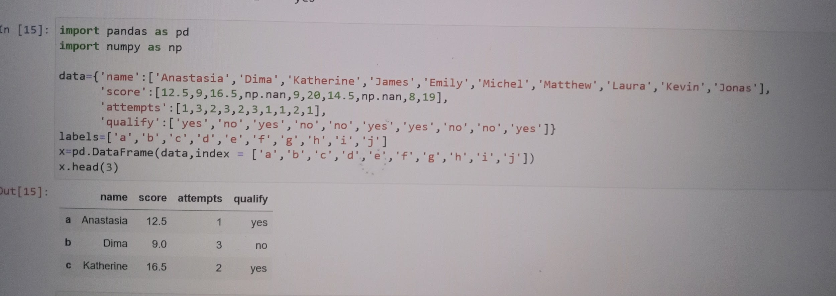

##4.Write a Pandas program to select the 'name' and 'score' columns from the following DataFrame.

Sample Python dictionary data and list labels:

exam_data = {'name': ['Anastasia', 'Dima', 'Katherine', 'James', 'Emily', 'Michael', 'Matthew', 'Laura', 'Kevin', 'Jonas'],

'score': [12.5, 9, 16.5, np.nan, 9, 20, 14.5, np.nan, 8, 19],

'attempts': [1, 3, 2, 3, 2, 3, 1, 1, 2, 1],

'qualify': ['yes', 'no', 'yes', 'no', 'no', 'yes', 'yes', 'no', 'no', 'yes']}

labels = ['a', 'b', 'c', 'd', 'e', 'f', 'g', 'h', 'i', 'j']

Expected Output:

Select specific columns:

name score

a Anastasia 12.5

b Dima 9.0

c Katherine 16.5

...

h Laura NaN

i Kevin 8.0

j Jonas 19.0

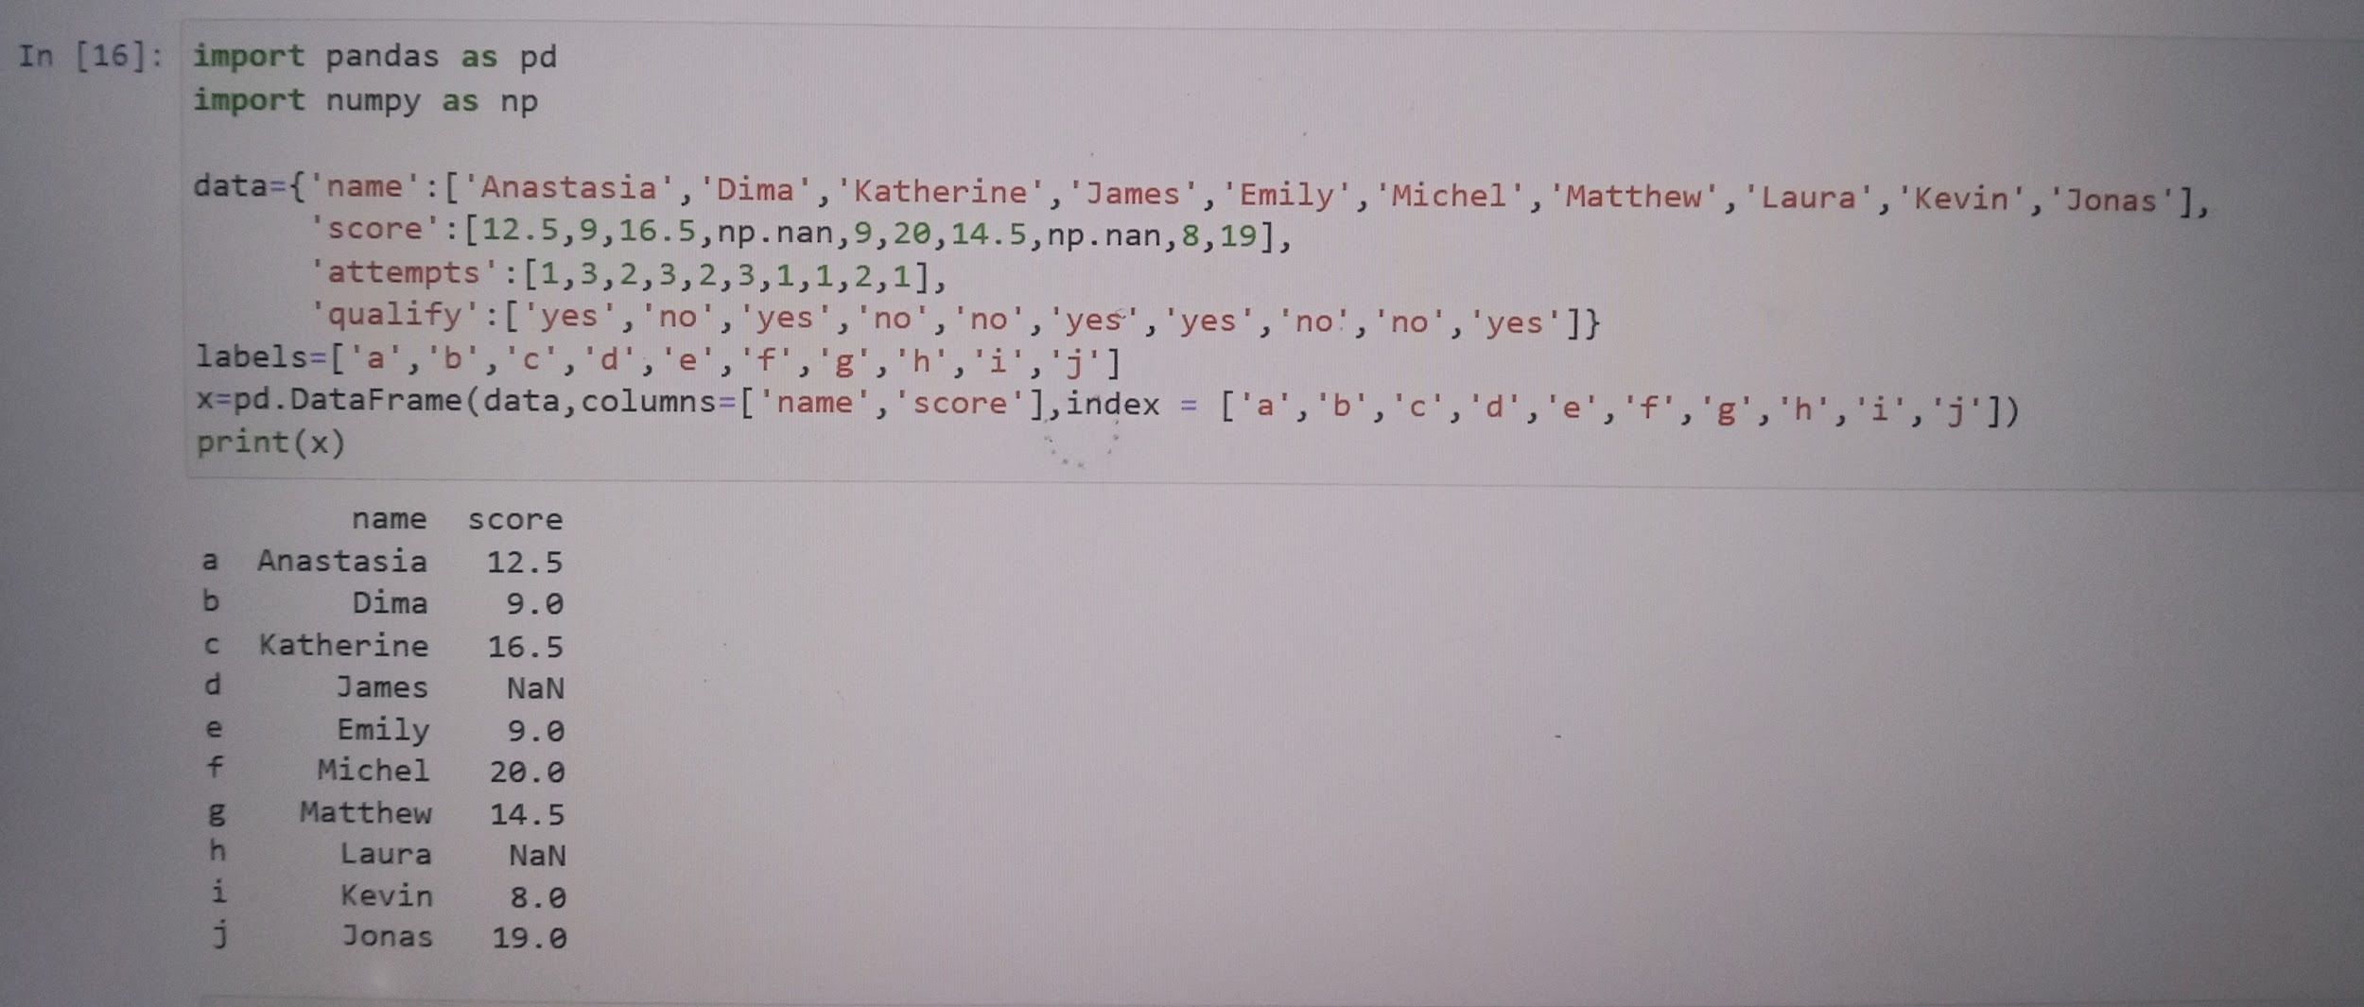

##6. Write a Pandas program to select the rows where the number of attempts in the examination is greater than 2.

Sample Python dictionary data and list labels:

exam_data = {'name': ['Anastasia', 'Dima', 'Katherine', 'James', 'Emily', 'Michael', 'Matthew', 'Laura', 'Kevin', 'Jonas'],

'score': [12.5, 9, 16.5, np.nan, 9, 20, 14.5, np.nan, 8, 19],

'attempts': [1, 3, 2, 3, 2, 3, 1, 1, 2, 1],

'qualify': ['yes', 'no', 'yes', 'no', 'no', 'yes', 'yes', 'no', 'no', 'yes']}

labels = ['a', 'b', 'c', 'd', 'e', 'f', 'g', 'h', 'i', 'j']

```

```

Expected Output:

Number of attempts in the examination is greater than 2:

name score attempts qualify

b Dima 9.0 3 no

d James NaN 3 no

f Michael 20.0 3 yes

```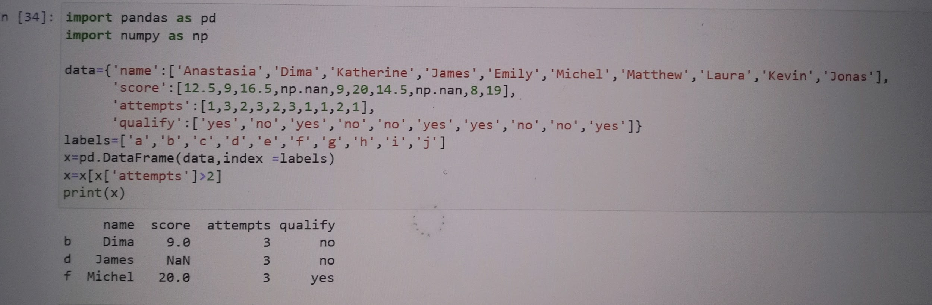

##7. Write a Pandas program to select the rows where the score is missing, i.e. is NaN.

```

Sample Python dictionary data and list labels:

exam_data = {'name': ['Anastasia', 'Dima', 'Katherine', 'James', 'Emily', 'Michael', 'Matthew', 'Laura', 'Kevin', 'Jonas'],

'score': [12.5, 9, 16.5, np.nan, 9, 20, 14.5, np.nan, 8, 19],

'attempts': [1, 3, 2, 3, 2, 3, 1, 1, 2, 1],

'qualify': ['yes', 'no', 'yes', 'no', 'no', 'yes', 'yes', 'no', 'no', 'yes']}

labels = ['a', 'b', 'c', 'd', 'e', 'f', 'g', labels = ['a', 'b', 'c', 'd', 'e', 'f', 'g', 'h', 'i', 'j']

```

```

Expected Output:

Rows where score is missing:

attempts name qualify score

d 3 James no NaN

h 1 Laura no NaN

```

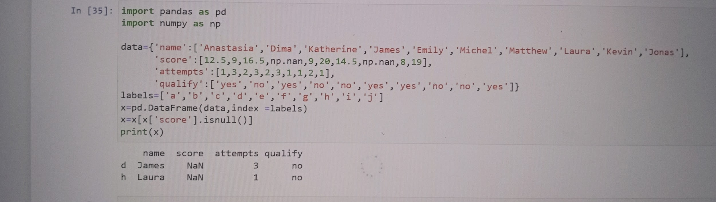

##8. Write a Pandas program to select the rows the score is between 15 and 20 (inclusive).

```

Sample Python dictionary data and list labels:

exam_data = {'name': ['Anastasia', 'Dima', 'Katherine', 'James', 'Emily', 'Michael', 'Matthew', 'Laura', 'Kevin', 'Jonas'],

'score': [12.5, 9, 16.5, np.nan, 9, 20, 14.5, np.nan, 8, 19],

'attempts': [1, 3, 2, 3, 2, 3, 1, 1, 2, 1],

'qualify': ['yes', 'no', 'yes', 'no', 'no', 'yes', 'yes', 'no', 'no', 'yes']}

labels = ['a', 'b', 'c', 'd', 'e', 'f', 'g', labels = ['a', 'b', 'c', 'd', 'e', 'f', 'g', 'h', 'i', 'j']

```

```

Expected Output:

Rows where score between 15 and 20 (inclusive):

attempts name qualify score

c 2 Katherine yes 16.5

f 3 Michael yes 20.0

j 1 Jonas yes 19.0

```

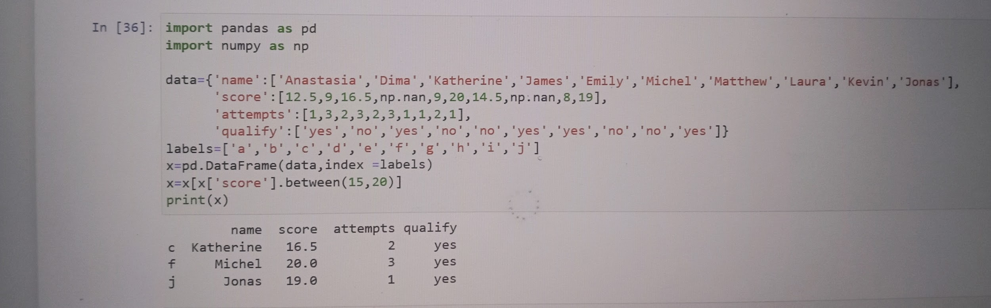

##9. Write a Pandas program to select the rows where number of attempts in the examination is less than 2 and score greater than 15.

```

Sample Python dictionary data and list labels:

exam_data = {'name': ['Anastasia', 'Dima', 'Katherine', 'James', 'Emily', 'Michael', 'Matthew', 'Laura', 'Kevin', 'Jonas'],

'score': [12.5, 9, 16.5, np.nan, 9, 20, 14.5, np.nan, 8, 19],

'attempts': [1, 3, 2, 3, 2, 3, 1, 1, 2, 1],

'qualify': ['yes', 'no', 'yes', 'no', 'no', 'yes', 'yes', 'no', 'no', 'yes']}

labels = ['a', 'b', 'c', 'd', 'e', 'f', 'g', labels = ['a', 'b', 'c', 'd', 'e', 'f', 'g', 'h', 'i', 'j']

```

```

Expected Output:

Number of attempts in the examination is less than 2 and score greater than 15 :

name score attempts qualify

j Jonas 19.0 1 yes

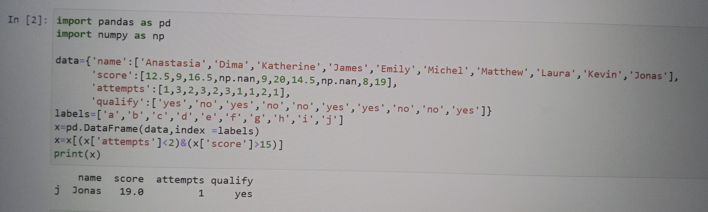

##10. Write a Pandas program to change the score in row 'd' to 11.5.

```

Sample Python dictionary data and list labels:

exam_data = {'name': ['Anastasia', 'Dima', 'Katherine', 'James', 'Emily', 'Michael', 'Matthew', 'Laura', 'Kevin', 'Jonas'],

'score': [12.5, 9, 16.5, np.nan, 9, 20, 14.5, np.nan, 8, 19],

'attempts': [1, 3, 2, 3, 2, 3, 1, 1, 2, 1],

'qualify': ['yes', 'no', 'yes', 'no', 'no', 'yes', 'yes', 'no', 'no', 'yes']}

labels = ['a', 'b', 'c', 'd', 'e', 'f', 'g', 'h', 'i', 'j']

Expected Output:

Change the score in row 'd' to 11.5:

attempts name qualify score

a 1 Anastasia yes 12.5

b 3 Dima no 9.0

c 2 Katherine yes 16.5

...

i 2 Kevin no 8.0

j 1 Jonas yes 19.0

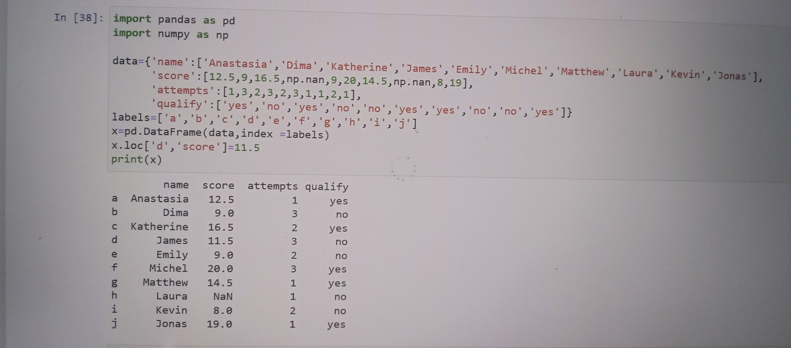

##11. Write a Pandas program to calculate the sum of the examination attempts by the students.

```

Sample Python dictionary data and list labels:

exam_data = {'name': ['Anastasia', 'Dima', 'Katherine', 'James', 'Emily', 'Michael', 'Matthew', 'Laura', 'Kevin', 'Jonas'],

'score': [12.5, 9, 16.5, np.nan, 9, 20, 14.5, np.nan, 8, 19],

'attempts': [1, 3, 2, 3, 2, 3, 1, 1, 2, 1],

'qualify': ['yes', 'no', 'yes', 'no', 'no', 'yes', 'yes', 'no', 'no', 'yes']}

labels = ['a', 'b', 'c', 'd', 'e', 'f', 'g', 'h', 'i', 'j']

Expected Output:

Sum of the examination attempts by the students:

19

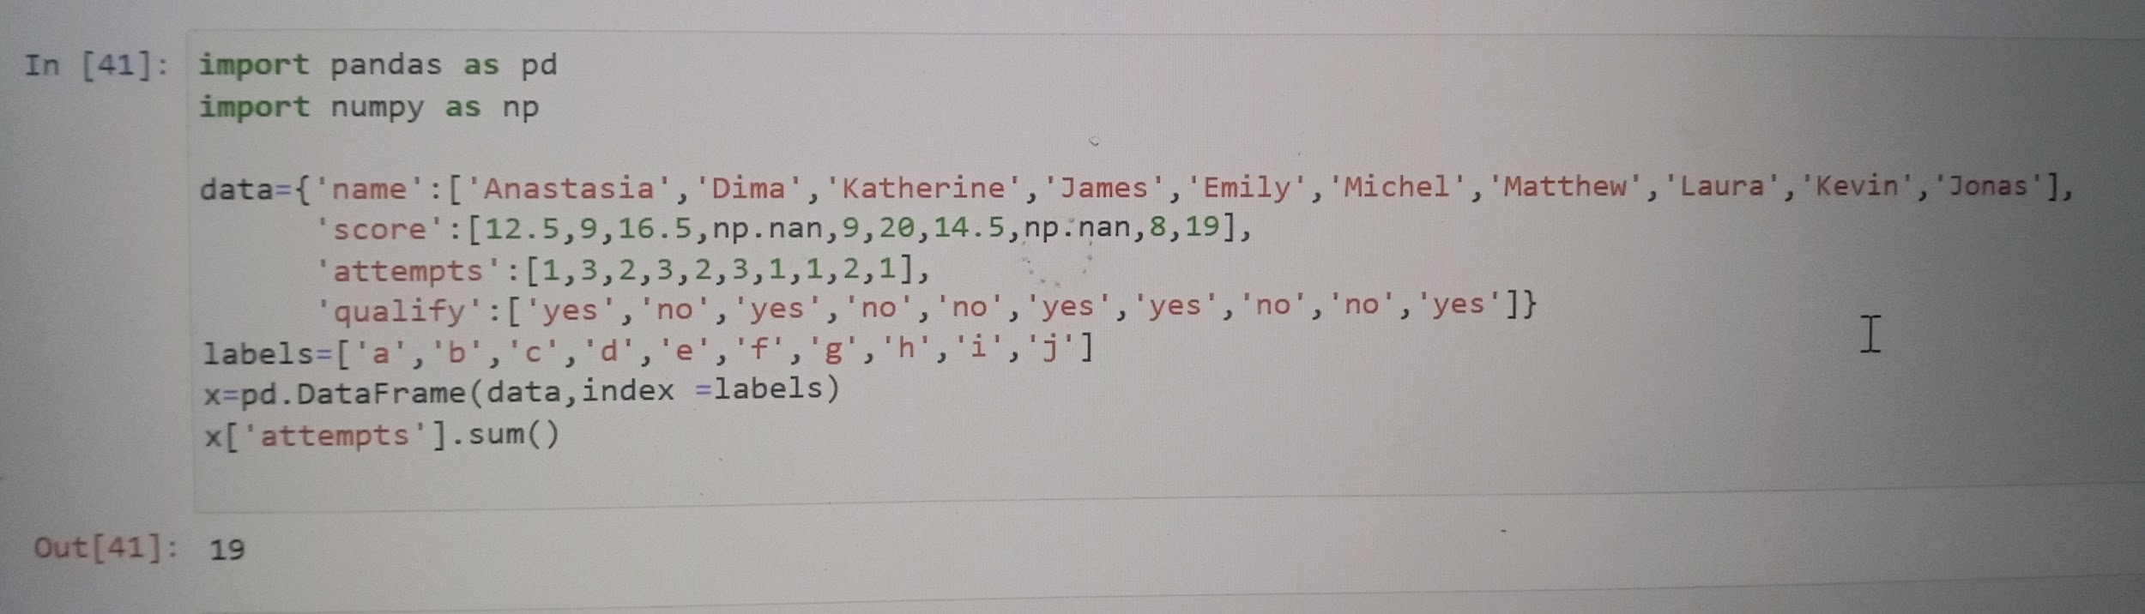

##12. Write a Pandas program to calculate the mean of all students' scores. Data is stored in a dataframe.

```

Sample Python dictionary data and list labels:

exam_data = {'name': ['Anastasia', 'Dima', 'Katherine', 'James', 'Emily', 'Michael', 'Matthew', 'Laura', 'Kevin', 'Jonas'],

'score': [12.5, 9, 16.5, np.nan, 9, 20, 14.5, np.nan, 8, 19],

'attempts': [1, 3, 2, 3, 2, 3, 1, 1, 2, 1],

'qualify': ['yes', 'no', 'yes', 'no', 'no', 'yes', 'yes', 'no', 'no', 'yes']}

labels = ['a', 'b', 'c', 'd', 'e', 'f', 'g', 'h', 'i', 'j']

`

Expected Output:

Mean score for each different student in data frame:

13.5625

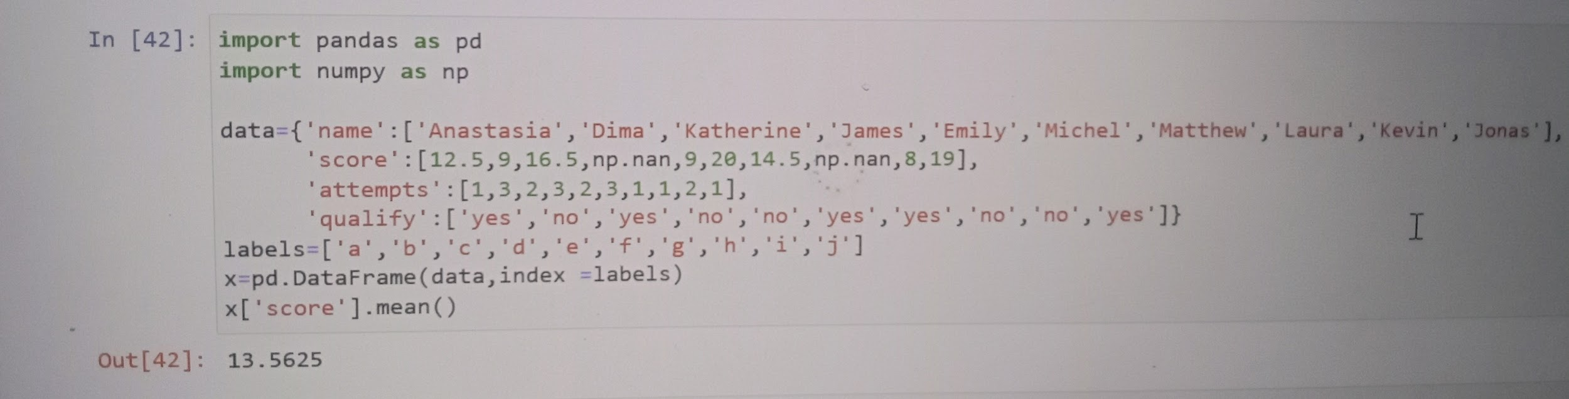

##13. Write a Pandas program to replace the 'qualify' column contains the values 'yes' and 'no' with True and False.

```

Sample Python dictionary data and list labels:

exam_data = {'name': ['Anastasia', 'Dima', 'Katherine', 'James', 'Emily', 'Michael', 'Matthew', 'Laura', 'Kevin', 'Jonas'],

'score': [12.5, 9, 16.5, np.nan, 9, 20, 14.5, np.nan, 8, 19],

'attempts': [1, 3, 2, 3, 2, 3, 1, 1, 2, 1],

'qualify': ['yes', 'no', 'yes', 'no', 'no', 'yes', 'yes', 'no', 'no', 'yes']}

labels = ['a', 'b', 'c', 'd', 'e', 'f', 'g', 'h', 'i', 'j']

Expected Output:

Replace the 'qualify' column contains the values 'yes' and 'no' with T

rue and False:

attempts name qualify score

a 1 Anastasia True 12.5

b 3 Dima False 9.0

......

i 2 Kevin False 8.0

j 1 Jonas True 19.0

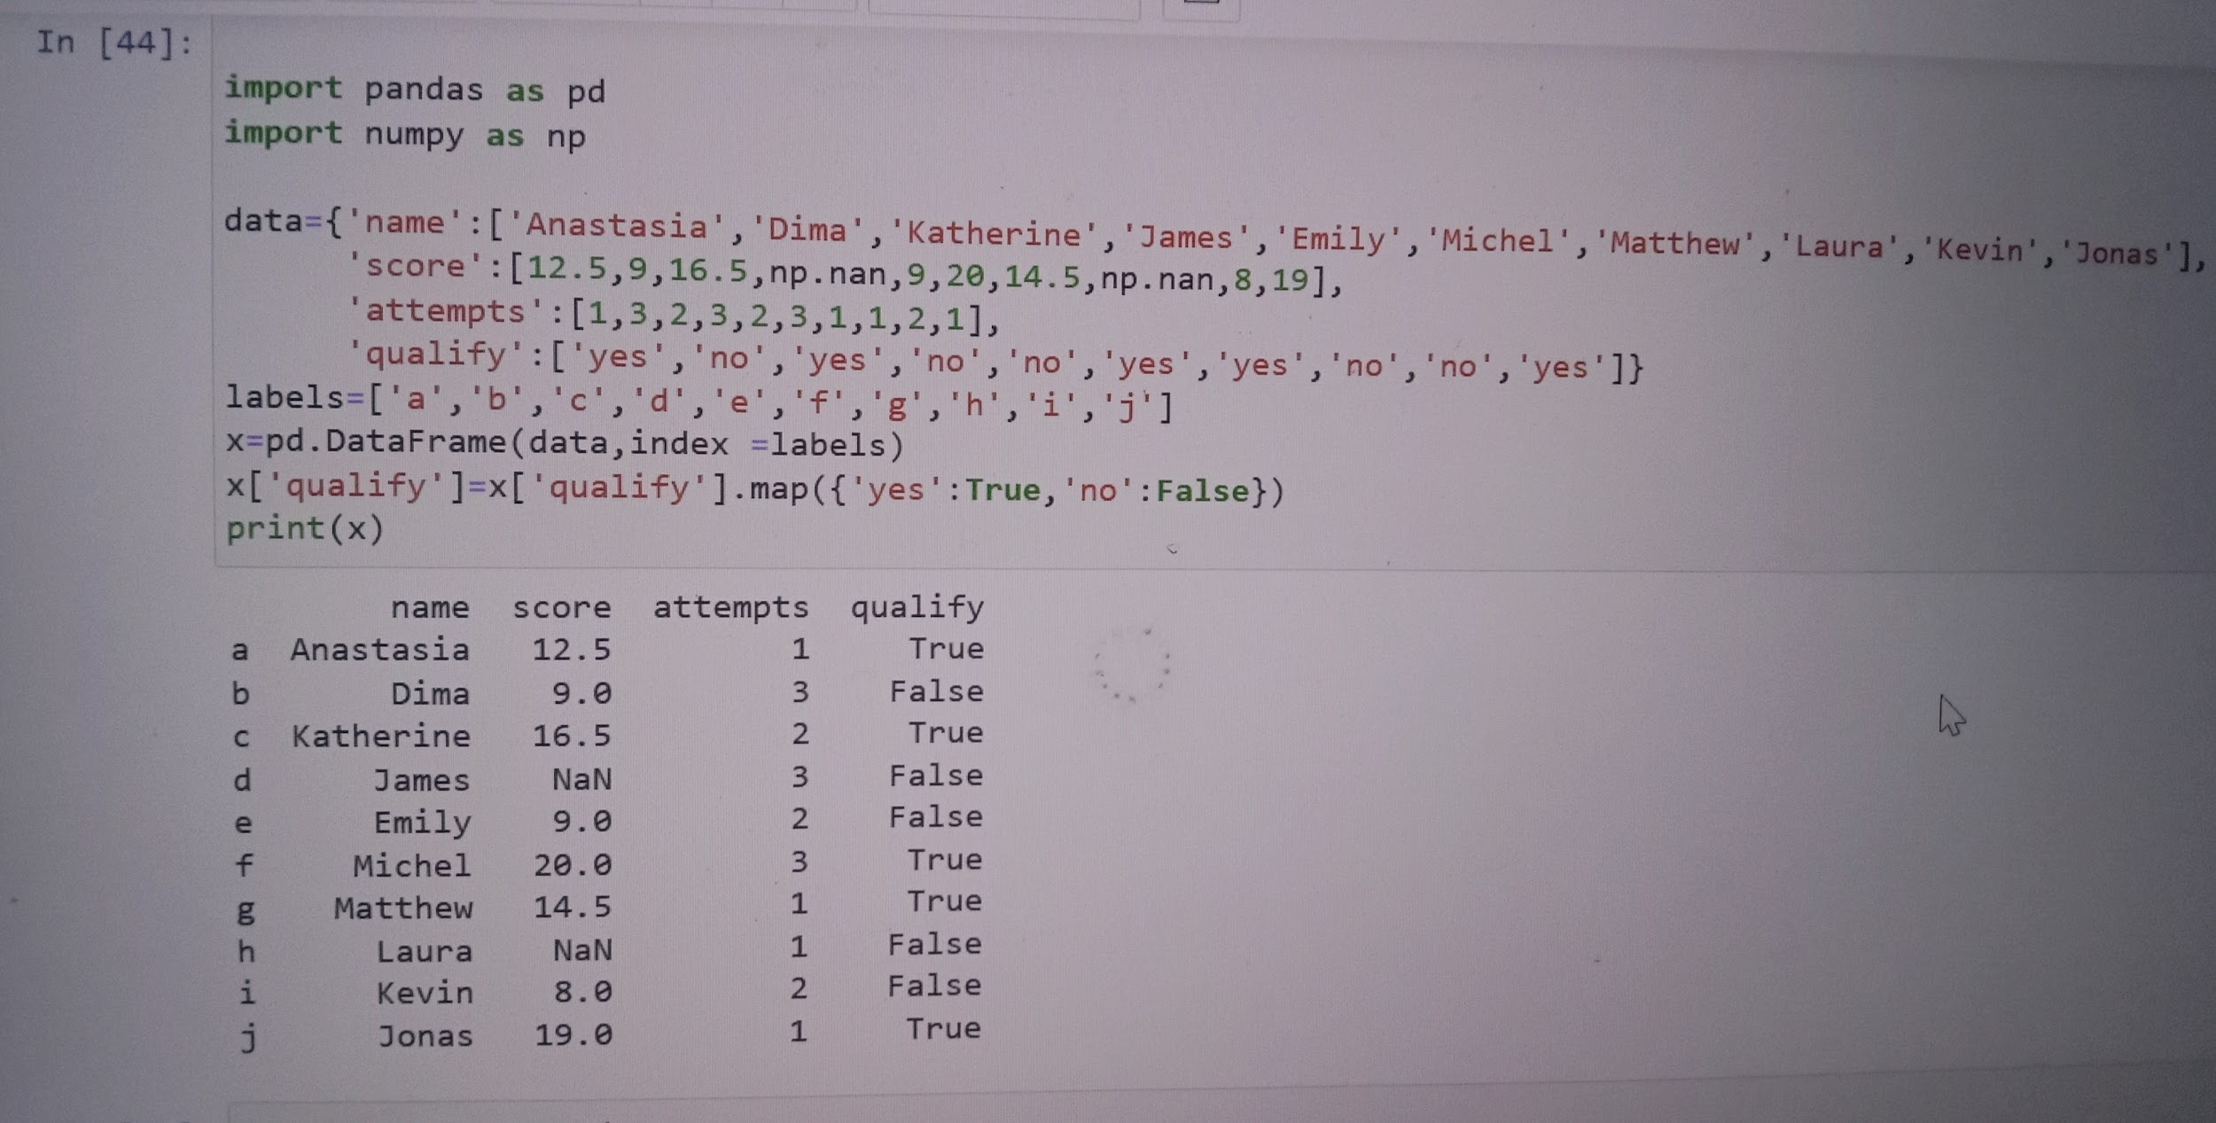

##14. Write a Pandas program to change the name 'James' to 'Suresh' in name column of the DataFrame.

Sample Python dictionary data and list labels:

exam_data = {'name': ['Anastasia', 'Dima', 'Katherine', 'James', 'Emily', 'Michael', 'Matthew', 'Laura', 'Kevin', 'Jonas'],

'score': [12.5, 9, 16.5, np.nan, 9, 20, 14.5, np.nan, 8, 19],

'attempts': [1, 3, 2, 3, 2, 3, 1, 1, 2, 1],

'qualify': ['yes', 'no', 'yes', 'no', 'no', 'yes', 'yes', 'no', 'no', 'yes']}

labels = ['a', 'b', 'c', 'd', 'e', 'f', 'g', 'h', 'i', 'j']

```

```

Expected Output:

Change the name 'James' to \?Suresh\?:

attempts name qualify score

a 1 Anastasia yes 12.5

b 3 Dima no 9.0

.......

i 2 Kevin no 8.0

j 1 Jonas yes 19.0

```

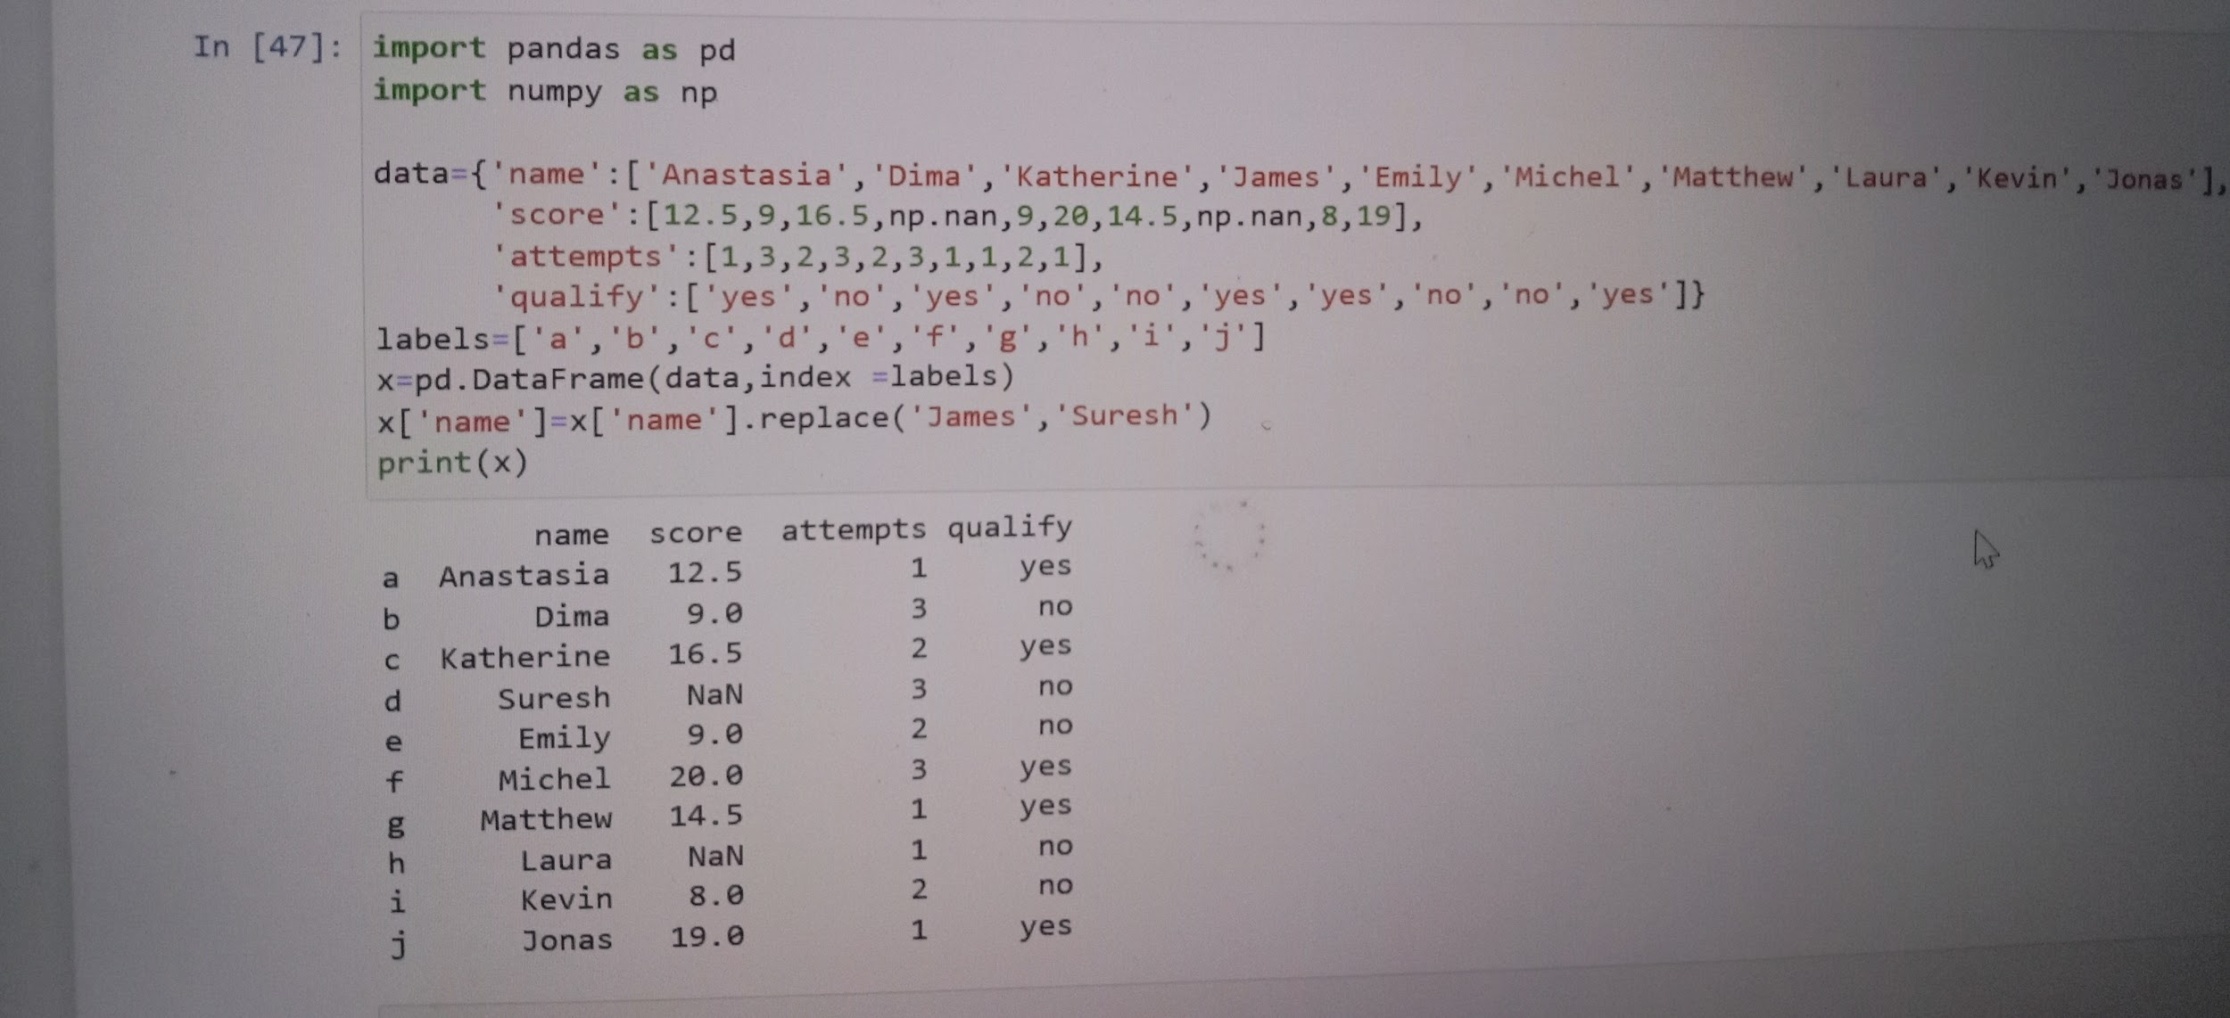

##15. Write a Pandas program to delete the 'attempts' column from the DataFrame.

```

Sample Python dictionary data and list labels:

exam_data = {'name': ['Anastasia', 'Dima', 'Katherine', 'James', 'Emily', 'Michael', 'Matthew', 'Laura', 'Kevin', 'Jonas'],

'score': [12.5, 9, 16.5, np.nan, 9, 20, 14.5, np.nan, 8, 19],

'attempts': [1, 3, 2, 3, 2, 3, 1, 1, 2, 1],

'qualify': ['yes', 'no', 'yes', 'no', 'no', 'yes', 'yes', 'no', 'no', 'yes']}

labels = ['a', 'b', 'c', 'd', 'e', 'f', 'g', 'h', 'i', 'j']

```

Expected Output:

Delete the 'attempts' column from the data frame:

name qualify score

a Anastasia yes 12.5

b Dima no 9.0

.....

i Kevin no 8.0

j Jonas yes 19.0

```

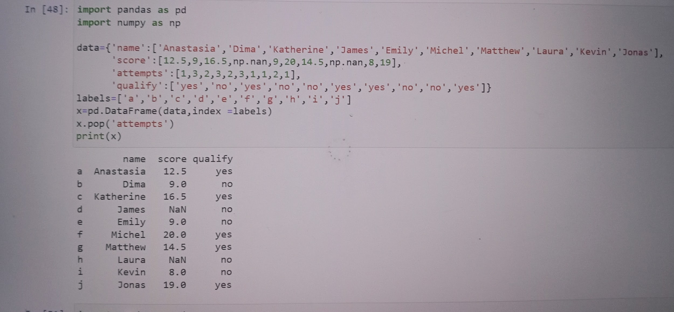

##16. Write a Pandas program to insert a new column in existing DataFrame.

Sample Python dictionary data and list labels:

exam_data = {'name': ['Anastasia', 'Dima', 'Katherine', 'James', 'Emily', 'Michael', 'Matthew', 'Laura', 'Kevin', 'Jonas'],

'score': [12.5, 9, 16.5, np.nan, 9, 20, 14.5, np.nan, 8, 19],

'attempts': [1, 3, 2, 3, 2, 3, 1, 1, 2, 1],

'qualify': ['yes', 'no', 'yes', 'no', 'no', 'yes', 'yes', 'no', 'no', 'yes']}

labels = ['a', 'b', 'c', 'd', 'e', 'f', 'g', 'h', 'i', 'j']

Expected Output:

New DataFrame after inserting the 'color' column

attempts name qualify score color

a 1 Anastasia yes 12.5 Red

b 3 Dima no 9.0 Blue

.......

i 2 Kevin no 8.0 Green

j 1 Jonas yes 19.0 Red

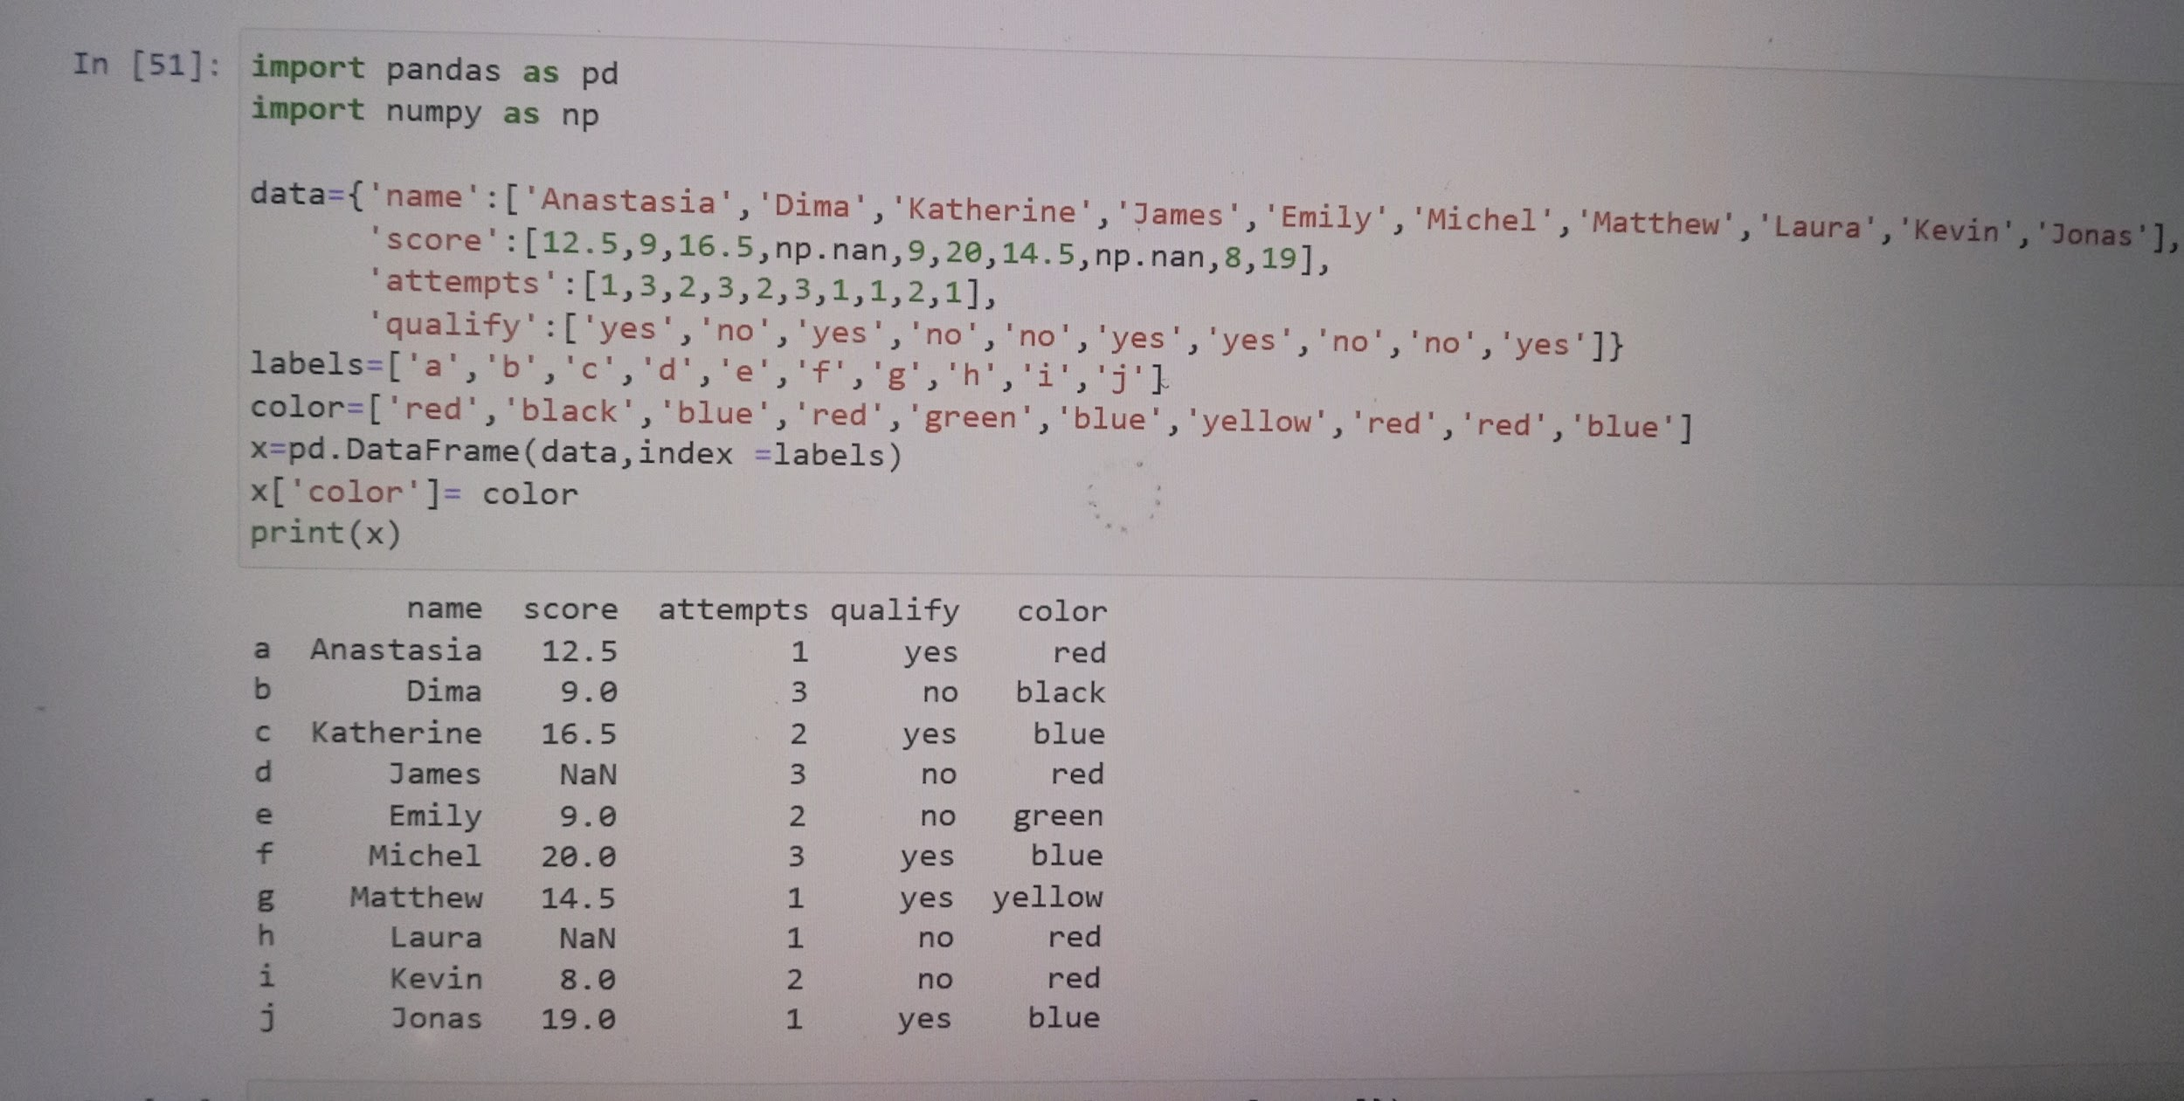

##17. Write a Pandas program to rename columns of a given DataFrame

```

Sample data:

Original DataFrame

col1 col2 col3

0 1 4 7

1 2 5 8

2 3 6 9

New DataFrame after renaming columns:

Column1 Column2 Column3

0 1 4 7

1 2 5 8

2 3 6 9

```

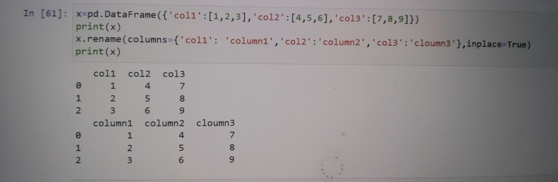

##18. Write a Pandas program to select rows from a given DataFrame based on values in some columns.

```

Sample data:

Original DataFrame

col1 col2 col3

0 1 4 7

1 4 5 8

2 3 6 9

3 4 7 0

4 5 8 1

Rows for colum1 value == 4

col1 col2 col3

1 4 5 8

3 4 7 0

``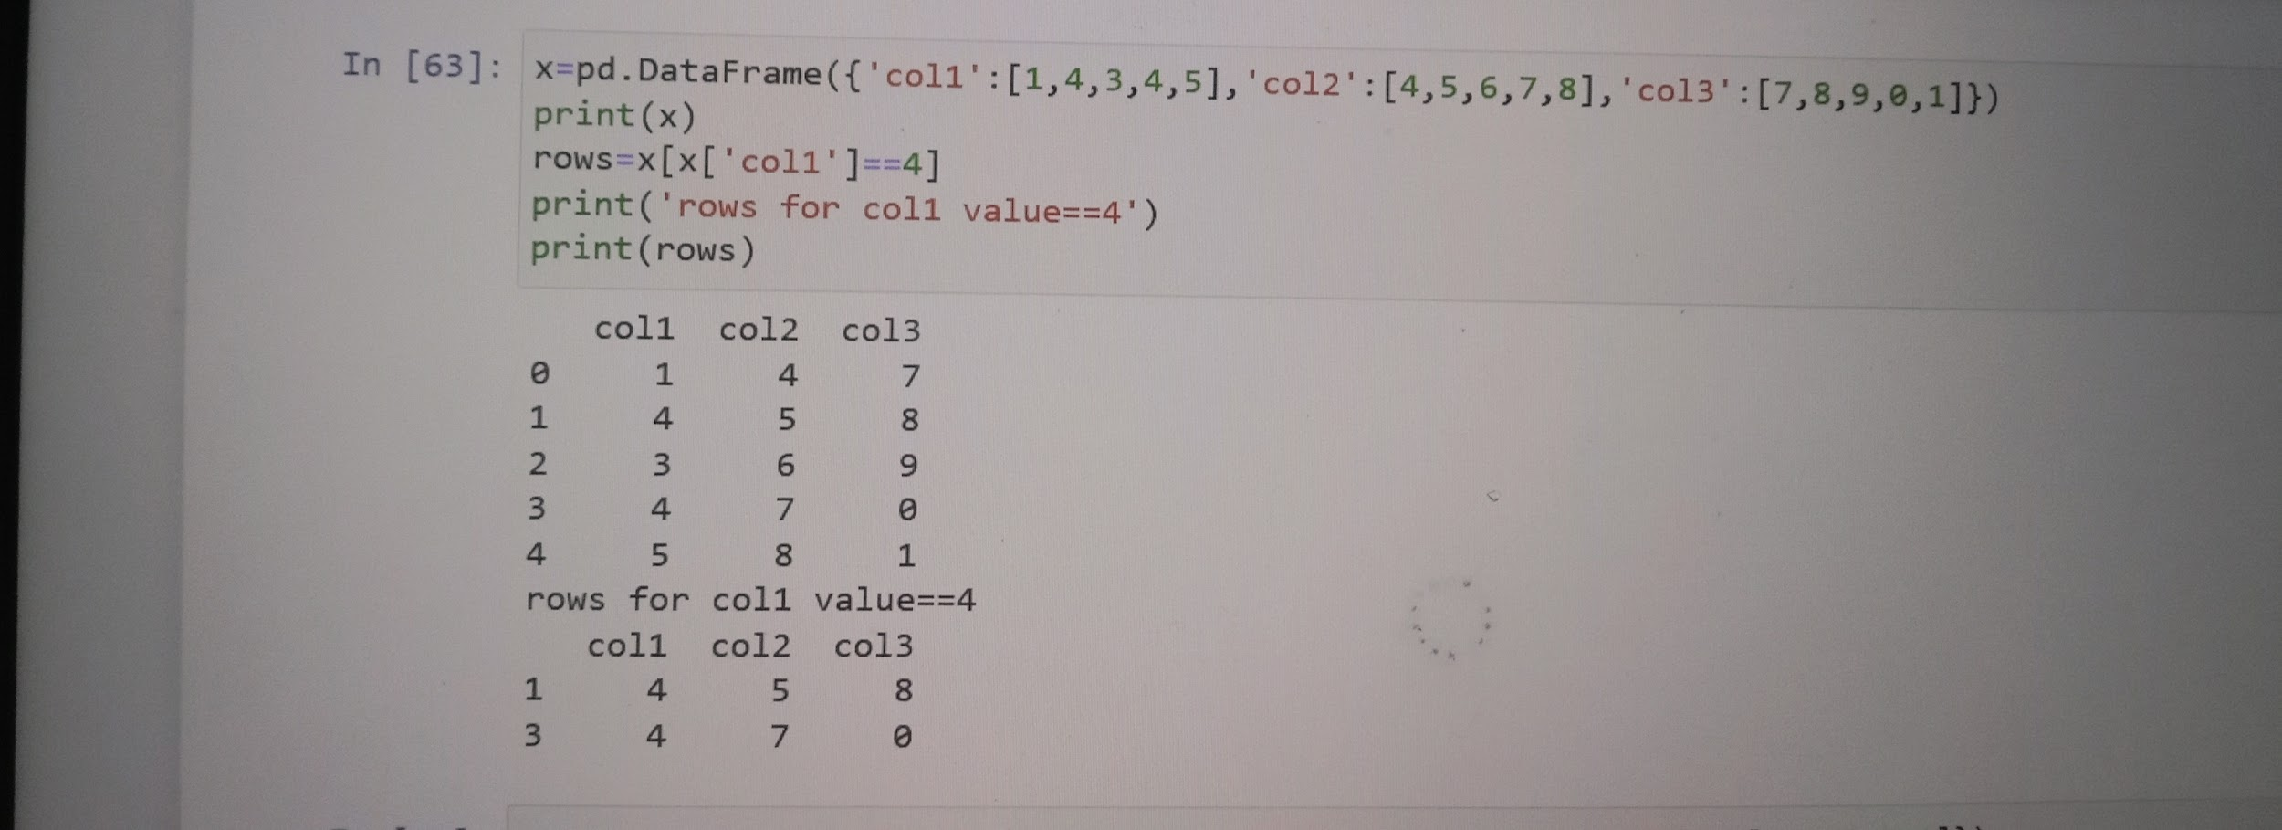

##19. Write a Pandas program to add one row in an existing DataFrame.

```

Sample data:

Original DataFrame

col1 col2 col3

0 1 4 7

1 4 5 8

2 3 6 9

3 4 7 0

4 5 8 1

After add one row:

col1 col2 col3

0 1 4 7

1 4 5 8

2 3 6 9

3 4 7 0

4 5 8 1

5 10 11 12

```

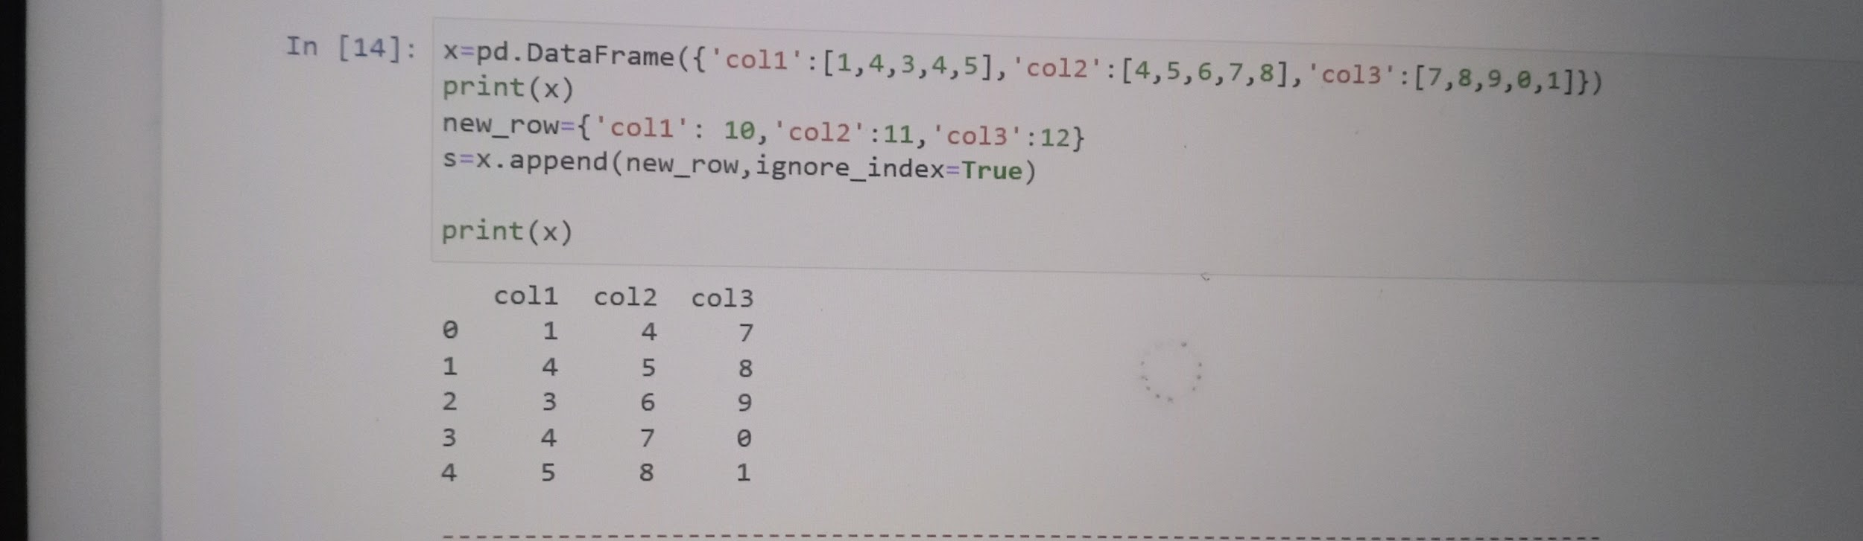

##20. Write a Pandas program to replace all the NaN values with Zero's in a column of a dataframe.

```

Sample data:

Original DataFrame

attempts name qualify score

0 1 Anastasia yes 12.5

1 3 Dima no 9.0

2 2 Katherine yes 16.5

.....

8 2 Kevin no 8.0

9 1 Jonas yes 19.0

New DataFrame replacing all NaN with 0:

attempts name qualify score

0 1 Anastasia yes 12.5

1 3 Dima no 9.0

2 2 Katherine yes 16.5

.....

8 2 Kevin no 8.0

9 1 Jonas yes 19.0

```

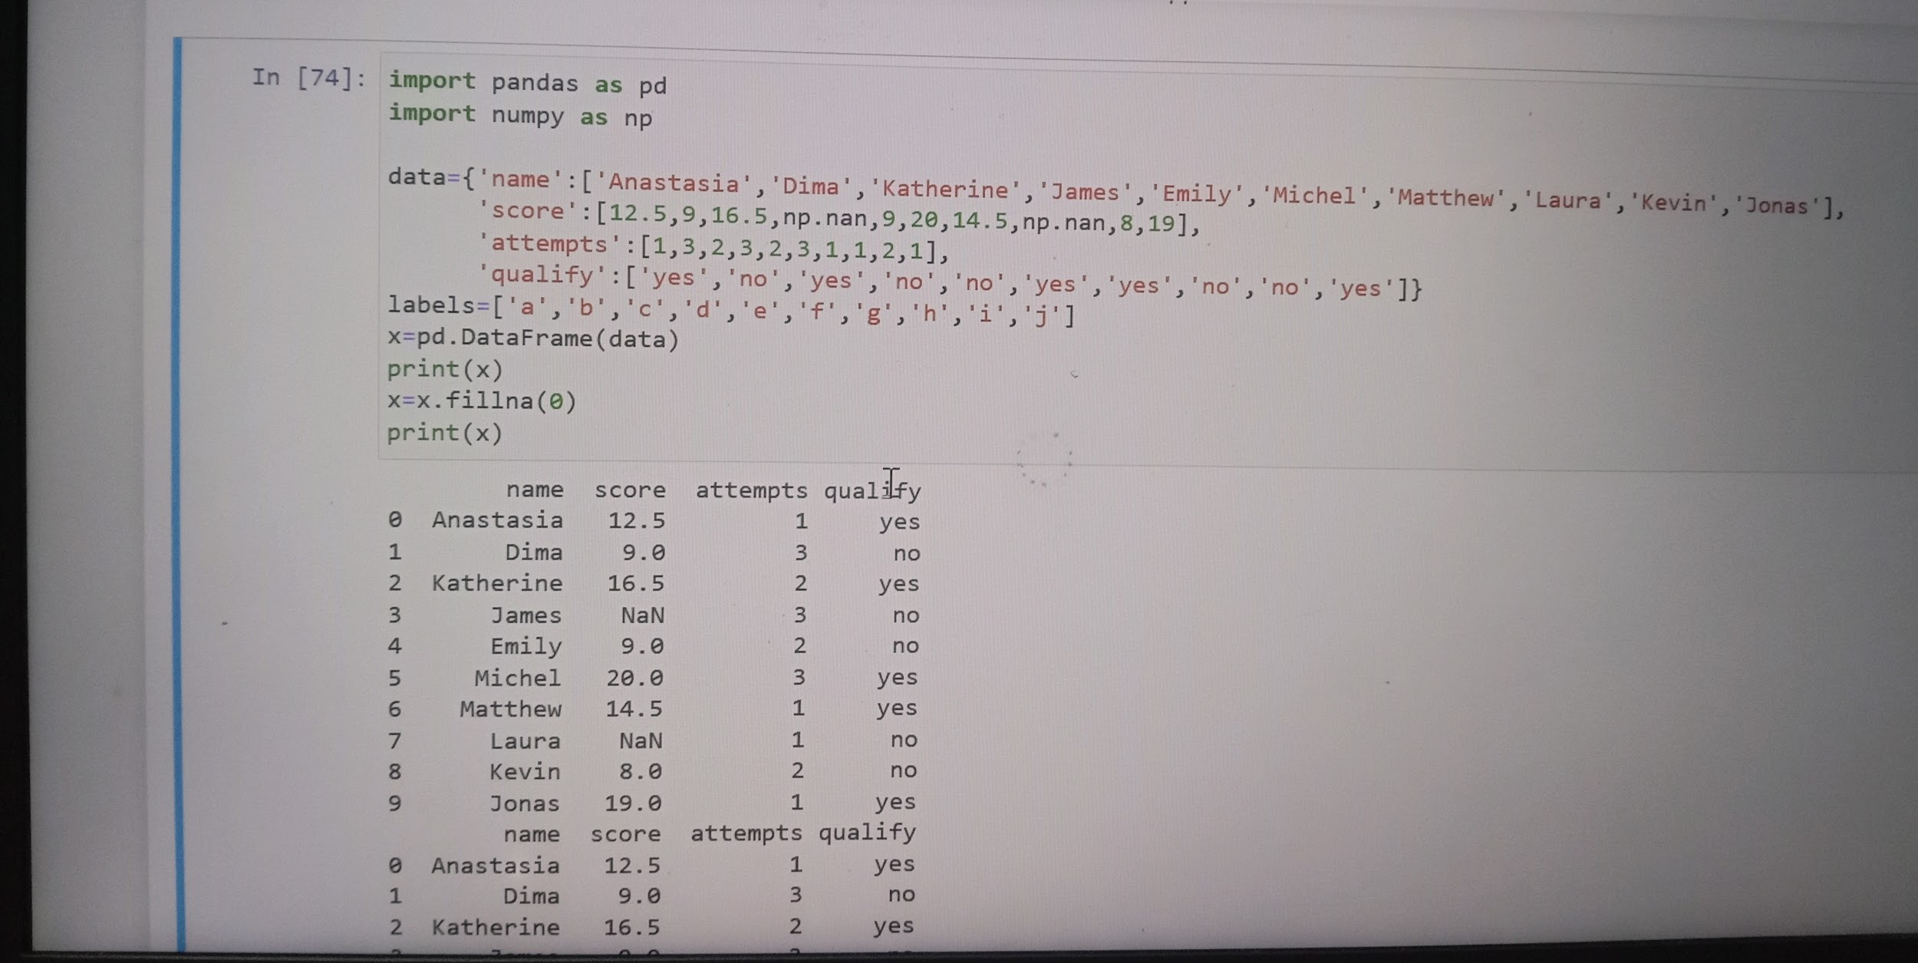

##21. Write a Pandas program to count the NaN values in one or more columns in DataFrame.

```

Sample data:

Original DataFrame

attempts name qualify score

0 1 Anastasia yes 12.5

1 3 Dima no 9.0

2 2 Katherine yes 16.5

3 3 James no NaN

4 2 Emily no 9.0

5 3 Michael yes 20.0

6 1 Matthew yes 14.5

7 1 Laura no NaN

8 2 Kevin no 8.0

9 1 Jonas yes 19.0

Number of NaN values in one or more columns:

2

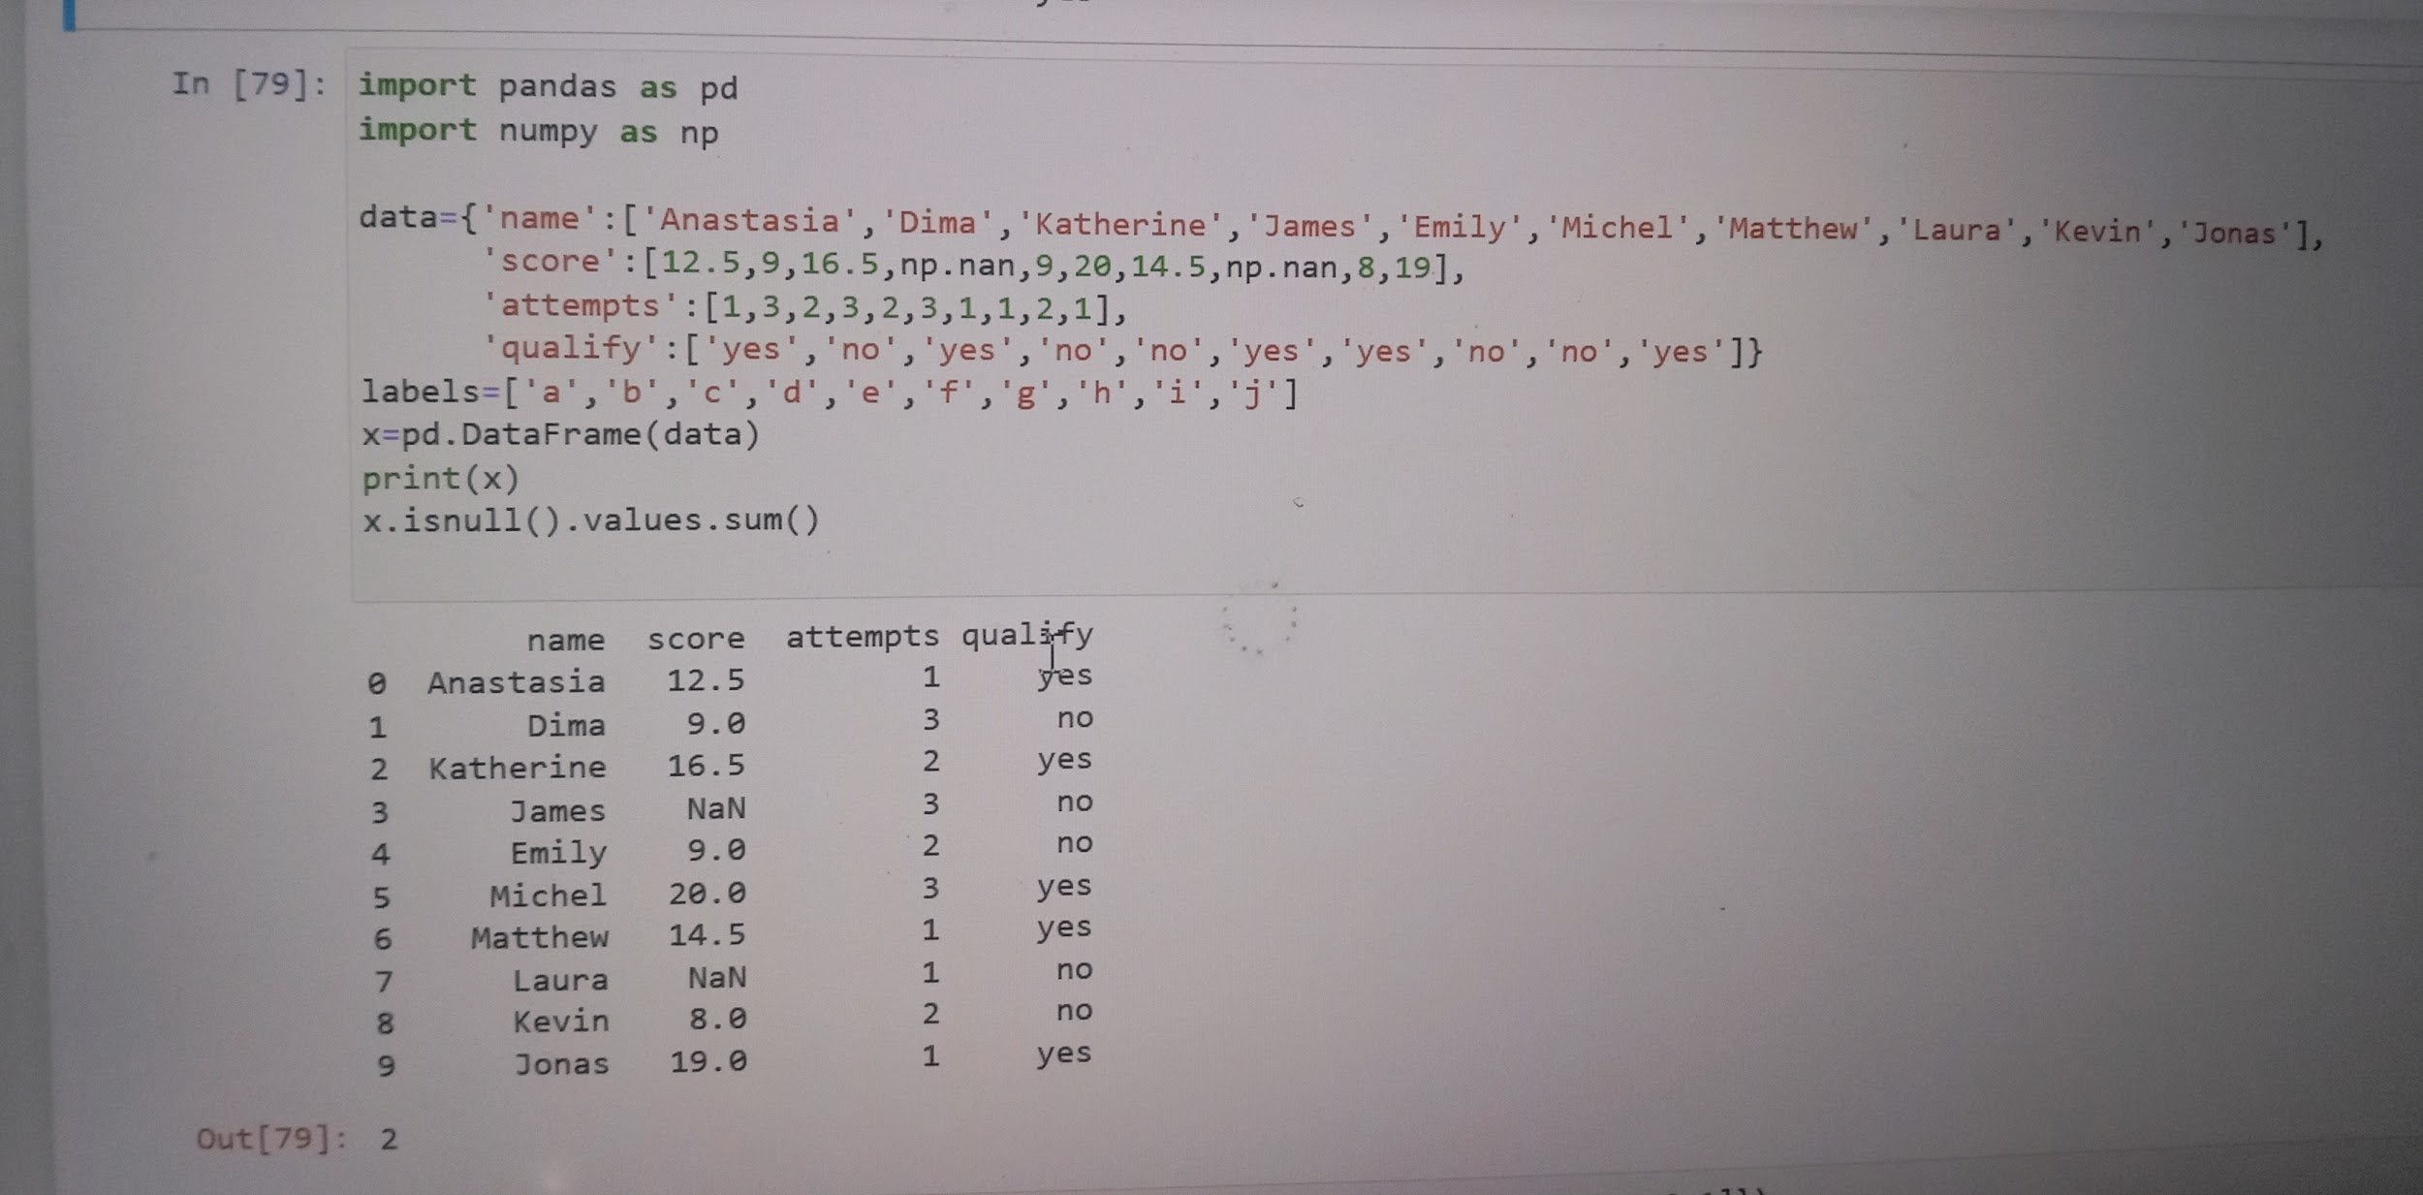

##22. Write a Pandas program to drop a list of rows from a specified DataFrame.

```

Sample data:

Original DataFrame

col1 col2 col3

0 1 4 7

1 4 5 8

2 3 6 9

3 4 7 0

4 5 8 1

New DataFrame after removing 2nd & 4th rows:

col1 col2 col3

0 1 4 7

1 4 5 8

3 4 7 0

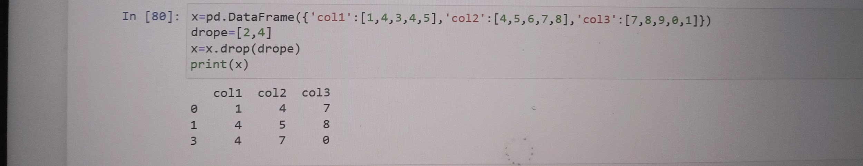

##23. . Write a Pandas program to convert DataFrame column type from string to datetime.

Sample data:

String Date:

0 3/11/2000

1 3/12/2000

2 3/13/2000

dtype: object

Original DataFrame (string to datetime):

0

0 2000-03-11

1 2000-03-12

2 2000-03-13

```

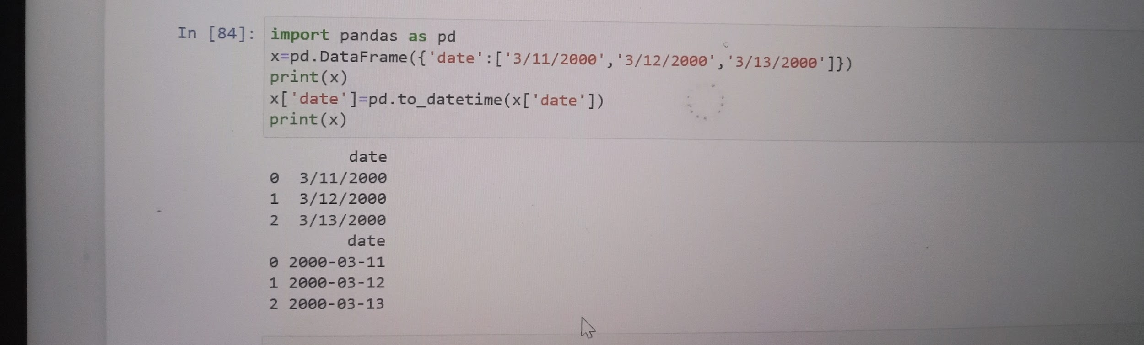

##24. Write a Pandas program to find the row for where the value of a given column is maximum.

Sample Output:

Original DataFrame

col1 col2 col3

0 1 4 7

1 2 5 8

2 3 6 12

3 4 9 1

4 7 5 11

Row where col1 has maximum value:

4

Row where col2 has maximum value:

3

Row where col3 has maximum value:

2

```

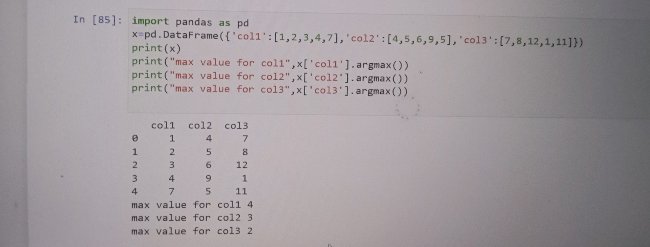

##25. Write a Pandas program to get the datatypes of columns of a DataFrame.

Sample data:

Original DataFrame:

attempts name qualify score

0 1 Anastasia yes 12.5

1 3 Dima no 9.0

.......

8 2 Kevin no 8.0

9 1 Jonas yes 19.0

Data types of the columns of the said DataFrame:

attempts int64

name object

qualify object

score float64

dtype: object

```

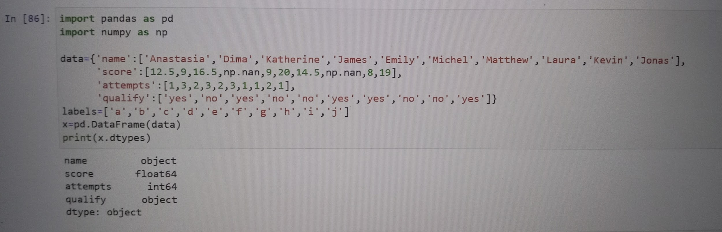

##27 Write a Pandas program to count number of columns of a DataFrame.

```

Sample Output:

Original DataFrame

col1 col2 col3

0 1 4 7

1 2 5 8

2 3 6 12

3 4 9 1

4 7 5 11

Number of columns:

3

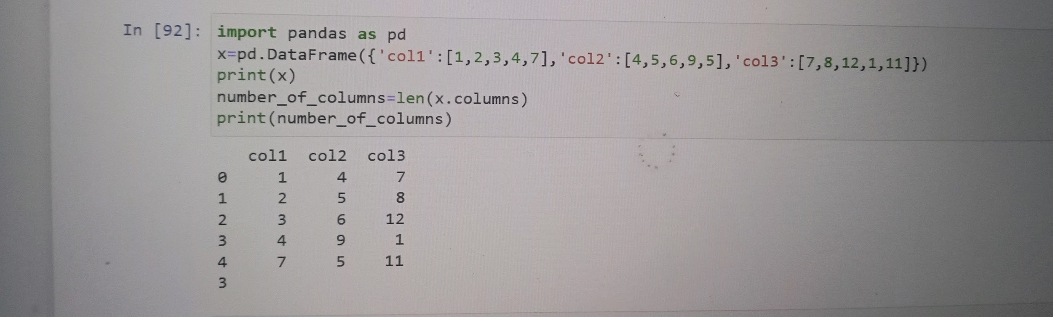

##28. Write a Pandas program to get first n records of a DataFrame.

```

Sample Output:

Original DataFrame

col1 col2 col3

0 1 4 7

1 2 5 5

2 3 6 8

3 4 9 12

4 7 5 1

5 11 0 11

First 3 rows of the said DataFrame':

col1 col2 col3

0 1 4 7

1 2 5 5

2 3 6 8

```

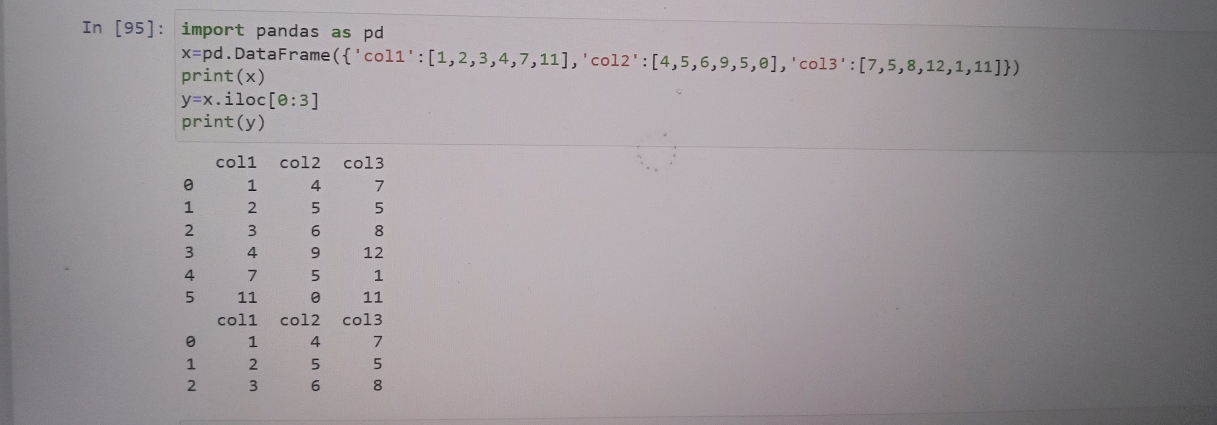

##29. Write a Pandas program to get last n records of a DataFrame.

Sample Output:

Original DataFrame

col1 col2 col3

0 1 4 7

1 2 5 5

2 3 6 8

3 4 9 12

4 7 5 1

5 11 0 11

Last 3 rows of the said DataFrame':

col1 col2 col3

3 4 9 12

4 7 5 1

5 11 0 11

```

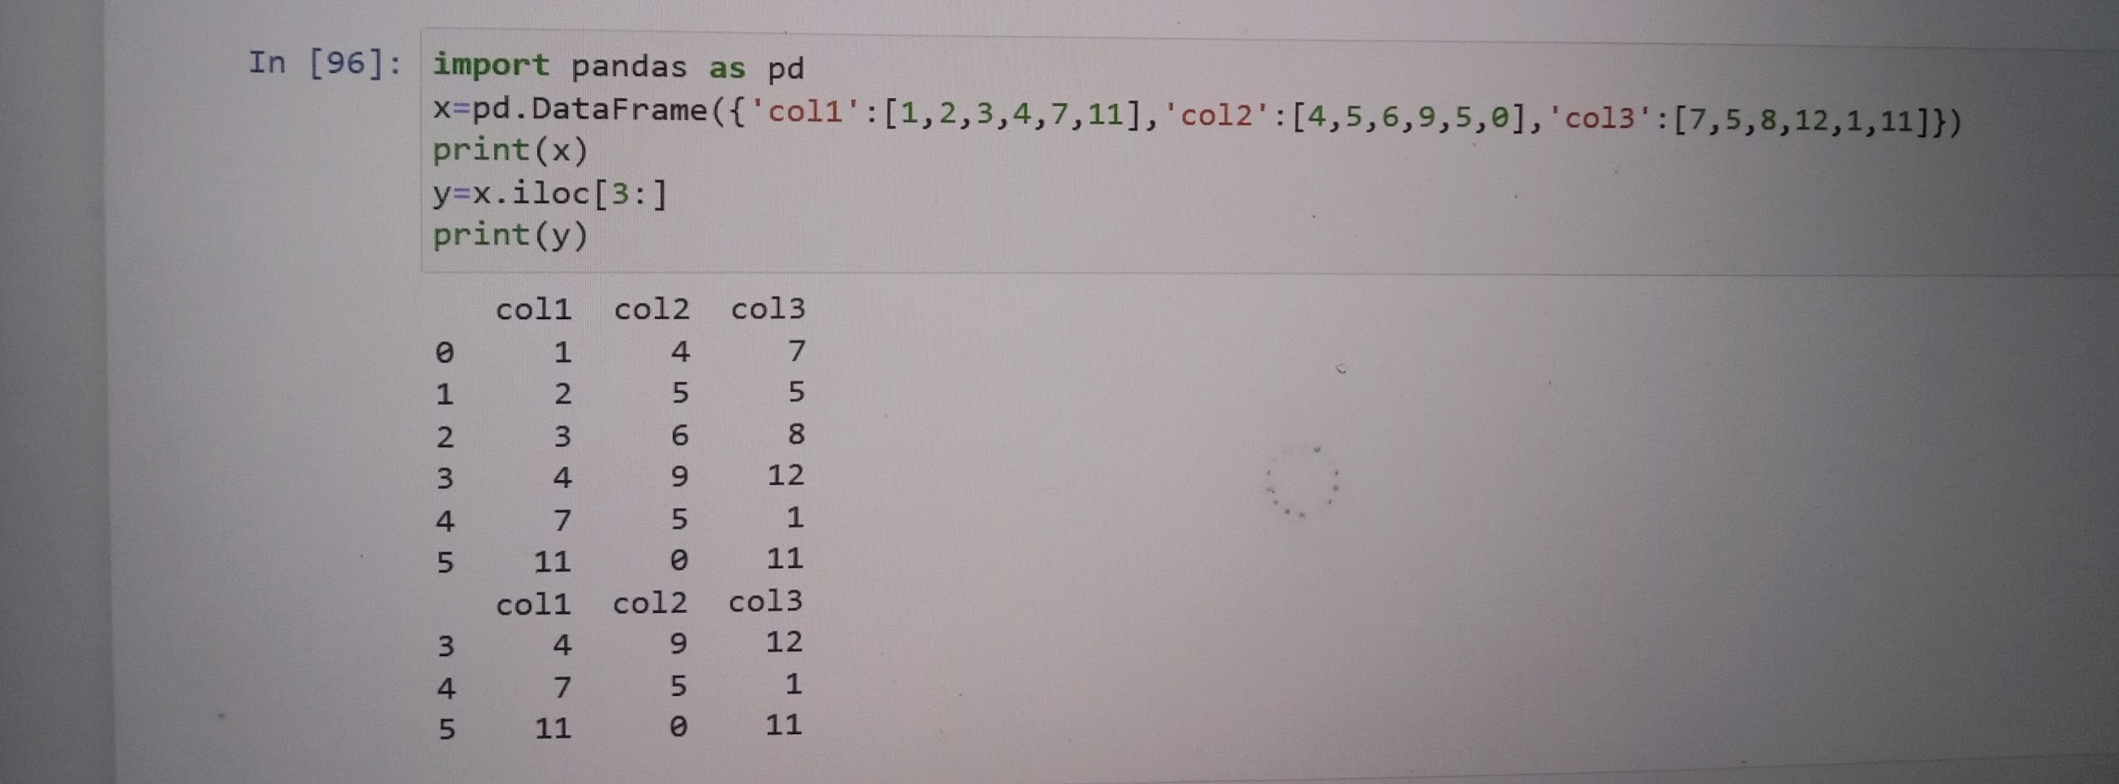

##30. Write a Pandas program to get topmost n records within each group of a DataFrame.

Sample Output:

Original DataFrame

col1 col2 col3

0 1 4 7

1 2 5 5

2 3 6 8

3 4 9 12

4 7 5 1

5 11 0 11

topmost n records within each group of a DataFrame:

col1 col2 col3

5 11 0 11

4 7 5 1

3 4 9 12

col1 col2 col3

3 4 9 12

2 3 6 8

1 2 5 5

4 7 5 1

col1 col2 col3

3 4 9 12

5 11 0 11

2 3 6 8

```

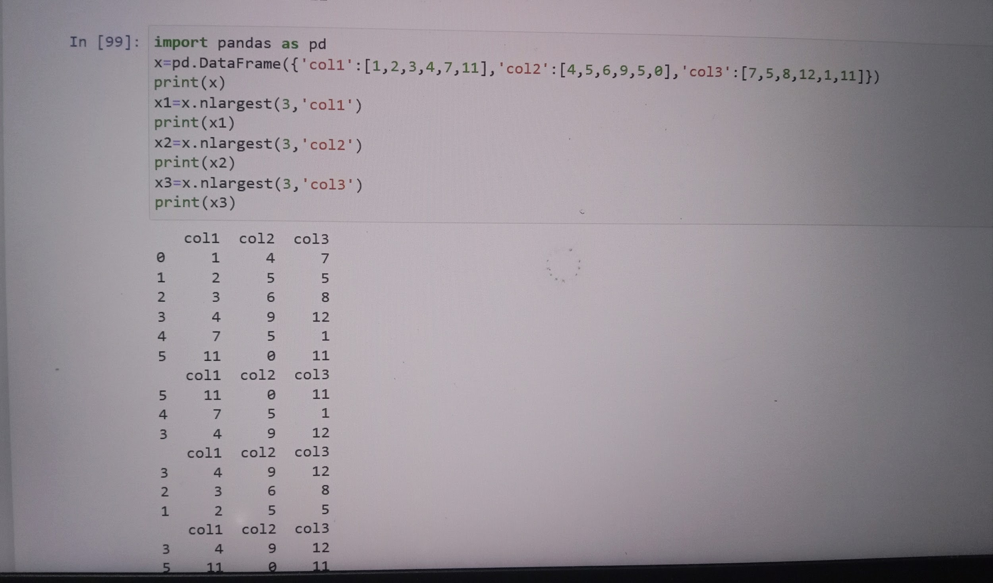

##31. Write a Pandas program to add a prefix or suffix to all columns of a given DataFrame.

```

Sample Output:

Original DataFrame

W X Y Z

0 68 78 84 86

1 75 85 94 97

2 86 96 89 96

3 80 80 83 72

4 66 86 86 83

Add prefix:

A_W A_X A_Y A_Z

0 68 78 84 86

1 75 85 94 97

2 86 96 89 96

3 80 80 83 72

4 66 86 86 83

Add suffix:

W_1 X_1 Y_1 Z_1

0 68 78 84 86

1 75 85 94 97

2 86 96 89 96

3 80 80 83 72

4 66 86 86 83

```

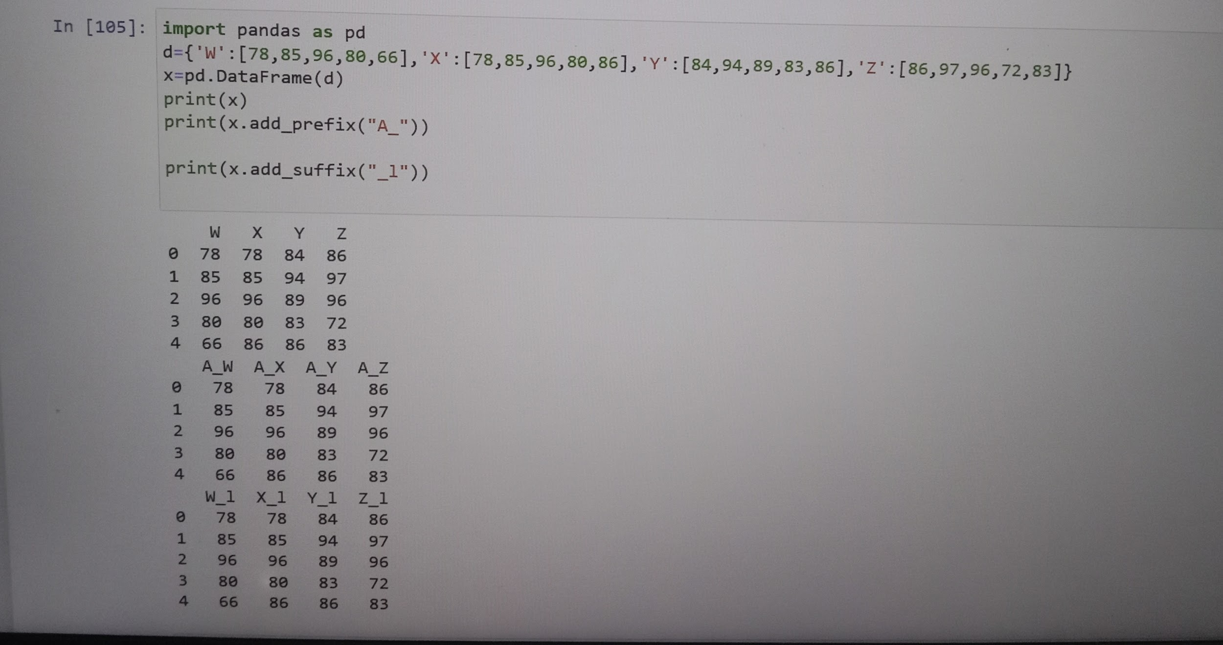

##32. Write a Pandas program to convert continuous values of a column in a given DataFrame to categorical.

```

Input:

{ 'Name': ['Alberto Franco','Gino Mcneill','Ryan Parkes', 'Eesha Hinton', 'Syed Wharton'],

'Age': [18, 22, 40, 50, 80, 5] }

Output:

Age group:

0 kids

1 adult

2 elderly

3 adult

4 elderly

5 kids

Name: age_groups, dtype: category

Categories (3, object): [kids < adult < elderly]

```

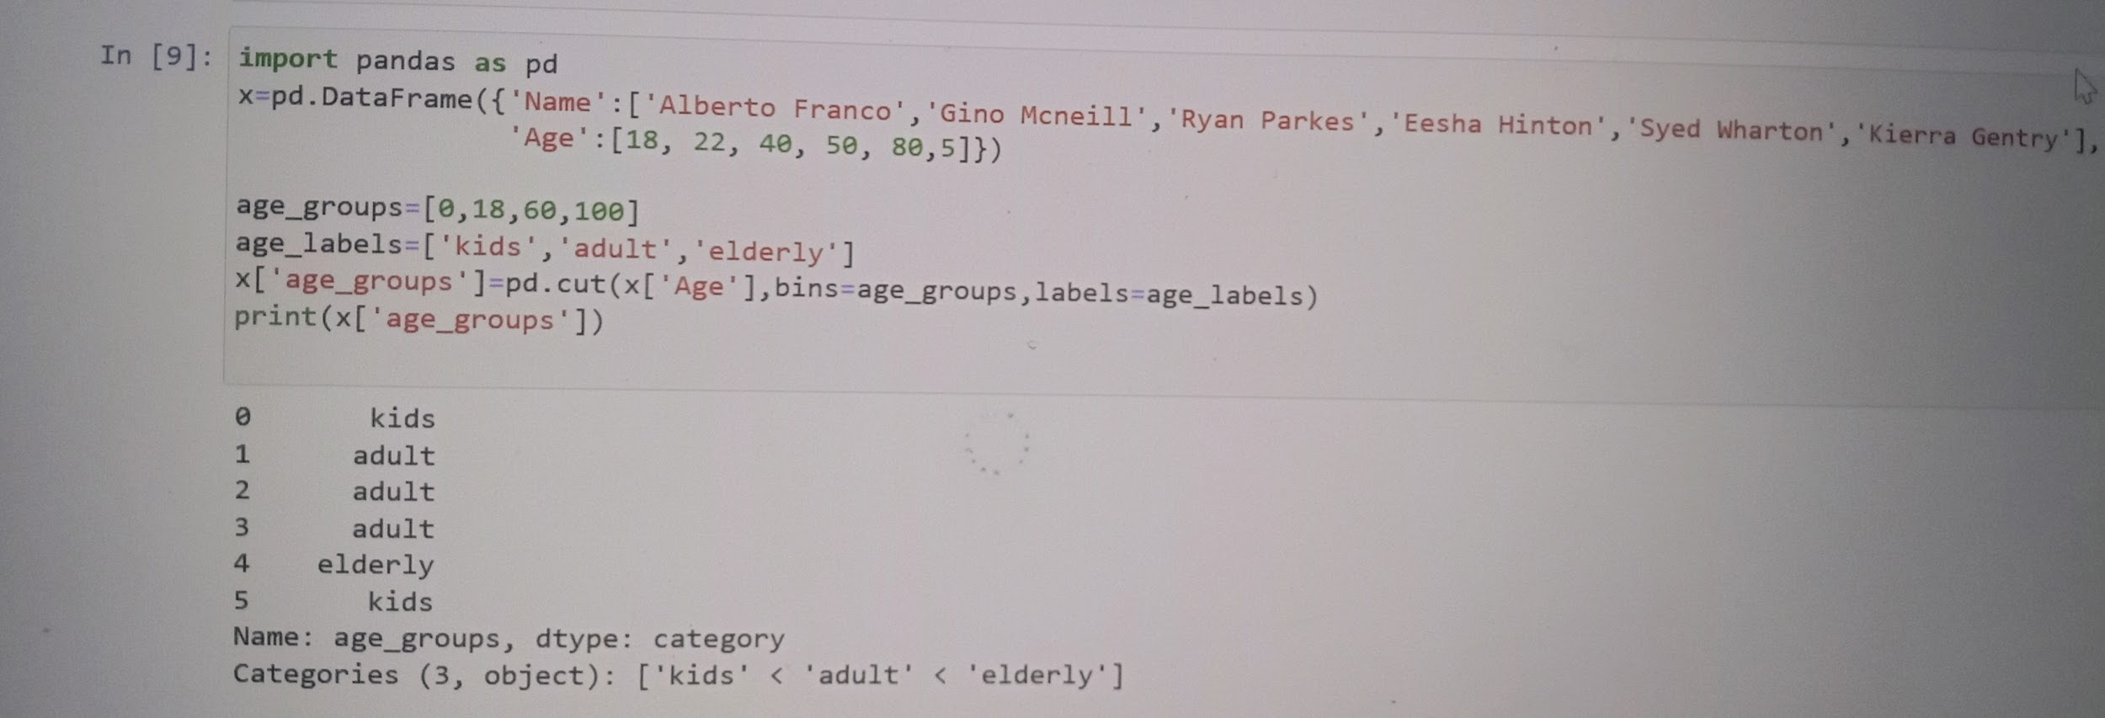

##33. Write a Pandas program to append rows to an existing DataFrame and display the combined data.

```

Test Data:

tudent_data1

student_id name marks

0 S1 Danniella Fenton 200

1 S2 Ryder Storey 210

2 S3 Bryce Jensen 190

3 S4 Ed Bernal 222

4 S5 Kwame Morin 199

New Row(s)

student_id S6

name Scarlette Fisher

marks 205

dtype: object

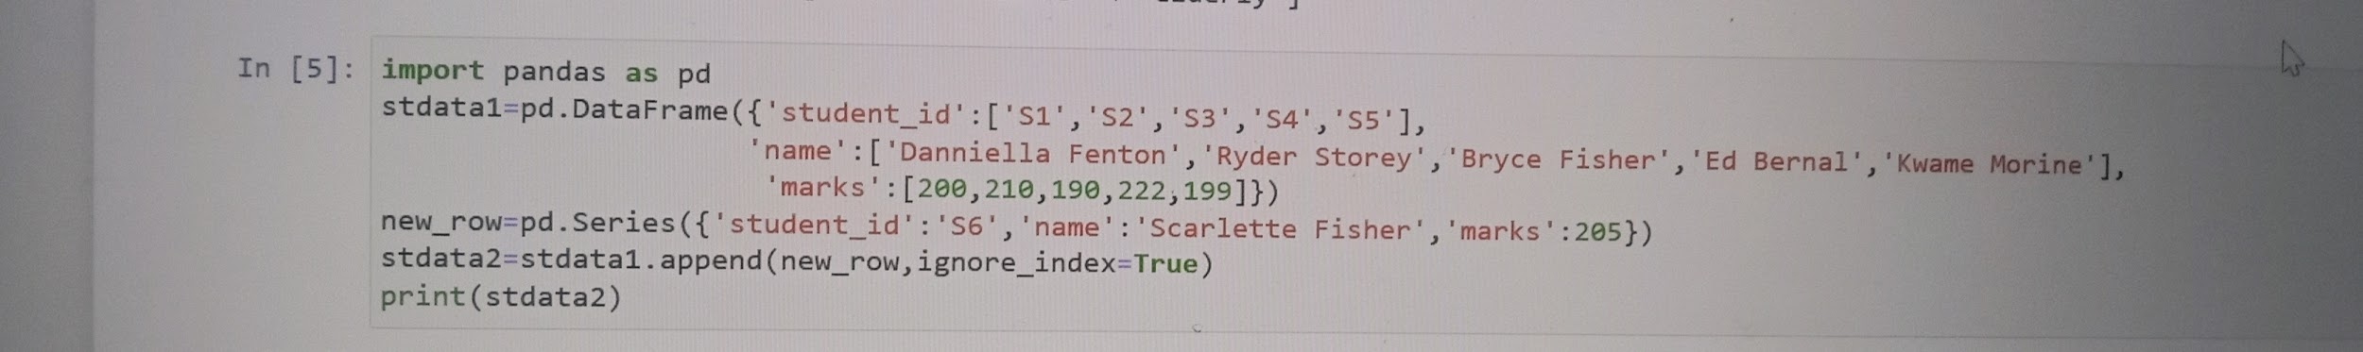

##34 Write a Pandas program to join the two given dataframes along rows and merge with another dataframe along the common column id.

Test Data:

student_data1:

student_id name marks

0 S1 Danniella Fenton 200

1 S2 Ryder Storey 210

2 S3 Bryce Jensen 190

3 S4 Ed Bernal 222

4 S5 Kwame Morin 199

student_data2:

student_id name marks

0 S4 Scarlette Fisher 201

1 S5 Carla Williamson 200

2 S6 Dante Morse 198

3 S7 Kaiser William 219

4 S8 Madeeha Preston 201

```

exam_data:

student_id exam_id

0 S1 23

1 S2 45

2 S3 12

3 S4 67

4 S5 21

5 S7 55

6 S8 33

7 S9 14

8 S10 56

9 S11 83

10 S12 88

11 S13 12

